A PROJECT REPORT ON

**“Face Anonymization for Privacy Preservation”**

**Submitted**

*In the partial fulfilment of the requirements for*

*The award of the degree of*

**BACHELOR OF TECHNOLOGY**

In

**COMPUTER SCIENCE & ENGINEERING**

By

**Shaik Mahaboob Subhani Sameer (171FA04298)**

**Kanagala Bhanu Murthi (171FA04339)**

Under the esteemed guidance of

**Mr.DS Bhupal Naik, Assistant Professor**





**DEPARTMENT OF COMPUTER SCIENCE & ENGINEERING**

**VIGNAN'S FOUNDATION FOR SCIENCE, TECHNOLOGY AND RESEARCH**

(**Accredited by NAAC “A” grade**)

**Vadlamudi, Guntur.**

**VIGNAN’S FOUNDATION FOR SCIENCE TECHNOLOGY AND**

**RESEARCH**

**(Accredited by NAAC “A” grade)**





**CERTIFICATE**

This is to certify that the Project Report entitled **“Face Anonymization for Privacy Preservation”** that is being submitted by **Shaik Mahaboob Subhani Sameer (171FA04298), Kanagala Bhanu Murthi (171FA04339)** in partial fulfilment for the award of B.Tech degree in Computer Science and Engineering to the Vignan’s Foundation for Science, Technology and Research, Deemed to be University, is a record of bonafide work carried out by them at **Department of CSE** under my supervision andco-guidance of the following faculty member of CSE Department.

**Mr. DS Bhupal Naik External Examiner Dr. Dondeti Venkatesulu Assistant Professor Professor, HOD**

**DECLARATION**

I hereby declare that the project entitled “**Face Anonymization for Privacy Preservation**” submitted for the **DEPARTMENT OF COMPUTER SCIENCE AND ENGINEERING**. This dissertation is our original work and the project has not formed the basis for the award of any degree, associate-ship and fellowship or any other similar titles and no part of it has been published or sent for publication at the time of submission.

By

**Shaik Mahaboob Subhani Sameer (171FA04298)**

**Kanagala Bhanu Murthi (171FA04339)**

Date:

# ACKNOWLEDGEMENT

Semester long project is a golden opportunity for learning and self-development. Consider myself very lucky and honoured to have so many wonderful people lead me through in the completion of this project.

We feel it is our responsibility to thank **Mr. DS Bhupal Naik** under whose valuable guidance that the project came out successfully after each stage, andalso it is our responsibility to extend our thanks to **Mr. D. Yakobu, Mr. P. Vijaya Babu, Dr. Balaji Vijayan, Department Project Coordinators,** for extending their support towards the completion of project in **Department of CSE**, in **VFSTR**.

It is a great pleasure for us to express our sincere thanks to **Dr. Venkatesulu Dondeti, HOD, CSE** of VFSTR Deemed to be University**,** for providing me an opportunity to do our project at Department of CSE.

It is our pleasure to extend our sincere thanks to **Vice-Chancellor** **Dr. M.Y.S. Prasad** and we are very grateful to our beloved **Chairman** **Dr. Lavu. Rathaiah**, and **Vice Chairman Mr. Lavu. Krishna Devarayalu**, for their love and care.

We extend our whole hearted gratitude to all our **faculty members** of Department of Computer Science and Engineering who helped us in our academics throughout course.

Finally, we wish to express thanks to our family members for the love and affection overseas and forbearance and cheerful depositions, which are vital for sustaining effort, required for completing this work.

With Sincere regards,

**Shaik Mahaboob Subhani Sameer (171FA04298)**

**Kanagala Bhanu Murthi (171FA04339)**

**Date:**

# ABSTRACT

The unprecedented increase in the usage of computer vision technology in society goes hand in hand with an increased concern in data privacy. In many real-world scenarios like people tracking or action recognition, it is important to be able to process the data while taking careful consideration in protecting people’s identity. Cameras are prevalent in our daily lives, and enable many useful systems built upon Computer Vision Technologies such as smart cameras and home robots for service applications. However, there is also an increasing societal concern as the captured images/videos may contain privacy-sensitive information (e.g., face identity). In this project we develop a novel architecture which is able to automatically anonymize faces in images while retaining the original data distribution. We ensure total anonymization of all faces in an image by generating images exclusively on privacy-safe information. Our model is based on a Generative Adversarial Networks (GANs) to create a model capable of generating realistic human images that do not exist in reality.  Furthermore, we introduce a diverse dataset of human faces, including unconventional poses, occluded faces, and a vast variability in backgrounds. A GAN takes a different approach to learning than other types of neural networks (NN). GANs algorithmic architectures that use two neural networks called a Generator and a Discriminator, which “compete” against one another to create the desired result. The Generator’s job is to create realistic looking fake images, while the Discriminator’s job is to distinguish between real images and fake images. If both are functioning at high levels, the result is images that are seemingly identical real-life photos. Finally, we present experimental results reflecting the capability of our model to anonymize images while preserving the data distribution, making the data suitable for further training of deep learning models with 80% Learning rate.

**Keywords:** Computer Vision (CV), Generative Adversarial Networks (GANs), Anonymization, Neural Networks, Generator, Discriminator, Deep Learning (DL)

**Table of Contents**

ACKNOWLEDGEMENT iii

ABSTRACT v

INTRODUCTION 1

1.1 Computer Vision 1

1.2 Face Anonymization 1

1.2.1 Related Work 2

1.2.2 Contributions 3

1.3 Generative Adversarial Networks 3

BACKGROUND STUDY 6

2.1 Literature Survey 6

2.2 Deep Learning 7

2.3 Neural Network 8

2.3.1 Layers 8

**2.3.2** Neural Network Architectures 17

2.4 Generative Adversarial Network (GAN) 20

2.4.1 Different Versions of Generative Adversarial Networks 21

PROPOSED WORK 27

3.1 Anonymizer Architecture 27

3.2 Generator Network: Encoder and Decoder 27

3.3 Objective Function 28

3.3.1 Recreation Loss 29

3.3.2 Adversarial Loss 30

3.4 Suggested Algorithm for Data Preparation 31

3.4.1 Iteration 1: Using existing database 31

3.4.2 Iteration 2: Cropping faces from public datasets 32

3.4.3 Iteration 3: Aligning, Scaling, and Centering face data 32

3.5 Suggested Algorithm for training of face anonymizer 33

3.6 Complete Pipeline 34

3.6.1 Pre-Processing 34

3.6.2 Anonymization 34

3.6.3 Post processing 34

IMPLEMENTATION 35

EXPERIMENTAL RESULTS 38

5.1 Training Results 38

5.2 Experiments to check ’Recreation Loss’ 38

5.3 Experiments with Face Masking 39

5.4 Experiments in Data Preparation 39

5.5 Experiment with Deeper network 41

5.6 Experiments with Recreation Loss function 42

5.7 Experiments with Joint Loss function 44

5.7.1 Iteration 1: λrec = 100 and λadv = 1 44

5.7.2 Iteration 2: λrec = 500 and λadv = 1 45

5.7.3 Iteration 3: λrec = 1000 and λadv = 1 45

CONCLUSION & FUTURE WORK 49

6.1 Conclusions 49

6.2 Future Work 49

REFERENCES 51

**List of Figures & Tables**

Figure 1.1: Traditional face anonymization techniques. From left Blurring, Pixelation and Black out…………………………………………………………………………………….2

Figure 1.2: Structure of a Generative Adversarial Network (GAN)………………………...3

Figure 1.3: Generator network in GANs…………………………………………………….4

Figure 1.4: Discriminator network in GANs………………………………………………...5

Figure 2.1: A biological neuron……………………………………………………………...9

Figure 2.2: Mathematical model of a neuron………………………………………………..10

Figure 2.3: Sigmoid non-linearity……………………………………………………………11

Figure 2.4: Tanh non-linearity……………………………………………………………….11

Figure 2.5: ReLU non-linearity………………………………………………………………12

Figure 2.6: Leaky ReLU non-linearity………………………………………………………13

Figure 2.7: Convolution mechanism with Input (Blue Matrix) and Output (Green Matrix), Filter size from left to right (3X3),(4X4) and (3X3)……………………………………………….14

Figure 2.8: Max pooling……………………………………………………………………...14

Figure 2.9: Pooling layer down samples the volume spatially, independently in each depth slice of the input volume…………………………………………………………………………..15

Figure 2.10: Deconvolution Layer……………………………………………………………15

Figure 2.11: An illustration of the unpooling operation………………………………………16

Figure 2.12: Structure of a Convolutional Neural Network (CNN)………………………….18

Figure 2.13: Structure of Autoencoder……………………………………………………….18

Figure 2.14: Basic structure of a Recurrent Neural Network (RNN)………………………...19

Figure 2.15: Working of a Recurrent Neural Network (RNN)……………………………......19

Figure 2.16: The structure of a Generative Adversarial Network (GAN)…………………....20

Figure 2.17: The structure of a Conditional Generative Adversarial Network (CGAN)…….21

Figure 2.18: The structure of a Laplacian Pyramid of Generative Adversarial Network (LAPGAN)…………………………………………………………………………………...22

Figure 2.19: The structure of a Deep Convolutional Generative Adversarial Network (DCGAN)…………………………………………………………………………………….23

Figure 2.20: The structure of an Adversarial Autoencoder (AAE)…………………………..24

Figure 2.21: The structure of a Generative Recurrent Adversarial Network (GRAN)………25

Figure 2.22: The structure of a Bidirectional Generative Adversarial Network (BiGAN)……………………………………………………………………………………26

Table 1. Comparison of different versions of GANs based on various criteria…………….26

Figure 3.1: Suggested architecture for Generator…………………………………………..28

Figure 3.2: Recreation loss: Masked Loss function………………………………………...29

Figure 3.3: Discriminator for Adversarial loss……………………………………………..31

Figure 3.4: Samples from ’celebA’ dataset…………………………………………………32

Figure 3.5: Cropped faces (Column 1), Aligned + Scaled + Cropped faces (Column 2) ………………………………………………………………………………………………33

Figure 5.1: Training progress for first 16 epochs (16*400,000/10 = 640,000 iterations)….38

Figure 5.2: a) Using existing dataset. b) Manual data preparation………………………….40

Figure 5.3: Results for aligned vs non-aligned test data…………………………………….41

Figure 5.4: Multimodal data distribution is 2d space represented with superimposition of 2 multivariate gaussian………………………………………………………………………..42

Figure 5.5: Fitting multimodal with unimodal distribution…………………………………43

Figure 5.6: Results with λrec = 100 and λadv = 1…………………………………..................44

Figure 5.7: Results with λrec = 500 and λadv = 1……………………………………………..45

Figure 5.8: Results with λrec = 1000 and λadv = 1……………………………………………46

Figure 5.9: Comparison: Joint Loss variations……………………………………………...46

Figure 5.10: Additional Results (both a and b) with λrec = 500 and λadv = 1 trained for 60k images of 256 × 256 resolution……………………………………………………………...47

Figure 5.11: Additional Results (both a and b) with λrec = 500 and λadv = 1 trained for 60k images of 256 × 256 resolution……………………………………………………………...47

Figure 5.12: Additional Results (both a and b) with λrec = 500 and λadv = 1 trained for 60k images of 256 × 256 resolution……………………………………………………………...48

Figure 5.13: Additional Results (both a and b) with λrec = 500 and λadv = 1 trained for 60k images of 256 × 256 resolution……………………………………………………………...48

**List of Abbreviations**

GDPR : General Data Protection Regulation

GAN : Generative Adversarial Network

AI : Artificial Intelligence

DL : Deep learning

NN : Neural Network

G : Generator

D : Discriminator

GNN : Generator Neural Network

DNN : Discriminator Neural Network

CBR : Convolution Batch-normalization RelU

DCBR : Deconvolution Batch-normalization

RelU

CNN : Convolutional Neural Network

RNN : Recurrent Neural Network

VAE : Variational Autoencoder

CGAN : Conditional Generative Adversarial

Network

DCGAN : Deep Convolutional Generative

Adversarial Network

LAPGAN : Laplacian Pyramid of Generative

Adversarial Network

AAE : Adversarial Autoencoder

GRAN : Generative Recurrent Adversarial

Network

BiGAN : Bidirectional Generative Adversarial

Network

ReLU : Rectified Linear Unit

LSE : Least Squares Error

LAD : Least Absolute Deviations

LAE : Least Absolute Error

**CHAPTER-1**

# INTRODUCTION

**1.1 Computer Vision**

Computer vision technology is enabling automatic understanding of large-scale visual data and is becoming a crucial component of many societal applications with ubiquitous cameras. For instance, cities are adopting networked camera systems for policing and intelligent resource allocation, individuals are recording their lives using wearable devices, and service robots at homes and public places are becoming increasingly popular.

Simultaneously, there is an increasing concern in these systems invading the privacy of their users; in particular, from unwanted video recording. On the one hand, we want the camera systems to recognize important events and assist human daily lives by understanding its videos, but on the other hand we want to ensure that they do not intrude the people’s privacy. Most computer vision algorithms require loading high resolution images/videos that can contain privacy-sensitive data to CPU/GPU memory to enable visual recognition.

They sometimes even require network access to high computing power servers, sending potentially privacy-sensitive images/videos. All these create a potential risk of one’s private visual data being snatched by someone else. In the worst case, the users are under the risk of being monitored by a hacker if their cameras/robots at home are cracked. There can also be hidden backdoors installed by the manufacturer, guaranteeing their access to cameras at one’s home.

**1.2 Face Anonymization**

To address these concerns, we need a principled way to ‘anonymize’ one’s videos/images. Existing anonymization methods include extreme down sampling or image masking, as well as more advanced image processing techniques using image segmentation. Although such techniques remove scene details in the images/videos in an attempt to protect privacy, they are based on heuristics rather than being learned, and there is no guarantee that they are optimal for privacy-protection. Moreover, they can hurt the ensuing visual recognition performance due to loss of information. Thus, a key challenge is creating an approach that can simultaneously anonymize videos, while ensuring that the anonymization does not negatively affect recognition performance.

In this project, we propose a novel principled approach for learning the video/image anonymizer. We use an adversarial training strategy; i.e., we model the learning process as a fight between two competing systems: (1) a video/image anonymizer that modifies the original video to remove privacy-sensitive information while preserving scene understanding performance, and (2) a discriminator that extracts privacy-sensitive information from such anonymized videos. We use human face identity as the representative private information since face is one of the strongest cues to infer a person’s identity and use action detection as the representative scene understanding task.

**1.2.1 Related Work**

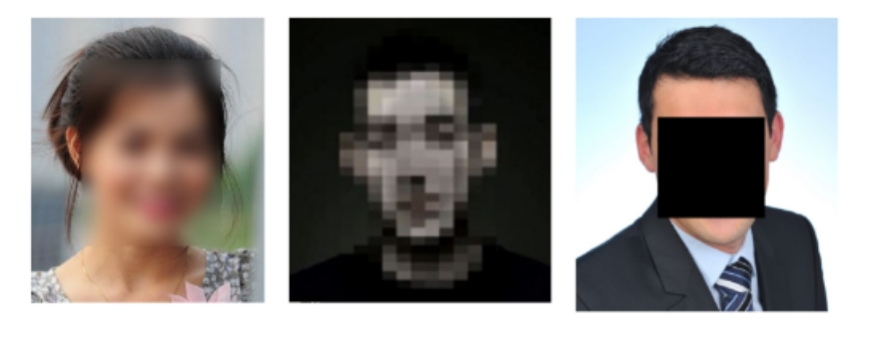**Image anonymization:** Traditional image anonymization techniques are implemented using image filtering approaches. They use simple methods such as blurring, pixelation and black-out. Gross demonstrated that high obfuscation methods fail to preserve utility for various tasks and low obfuscation method fails to protect privacy. McPherson demonstrated that simple neural networks could unmask common image obfuscation techniques like blurring and pixelation.

Figure 1.1: Traditional face anonymization techniques. From left Blurring, Pixelation and Black out.

**Image generation**: Generative models of natural images have been an interesting research topic recently. Goodfellow introduced realistic image generation using adversarial training. Karras recently improved image resolution by growing both the generator and discriminator progressively. Turchenko presents the development of several models of a deep convolutional variational auto-encoder (VAE). However, the generated images by a VAE are usually blurry.

**1.2.2 Contributions**

In this project we:

* design a prototype for a completely new method to anonymize faces which enable privacy protection while preserving data utility i.e., the data can still be used for artificial intelligence applications.
* construct a high-quality dataset of aligned, scaled and centered faces.
* suggest and compare various objective (loss) functions in terms of quality of anonymized photos.

**1.3 Generative Adversarial Networks**

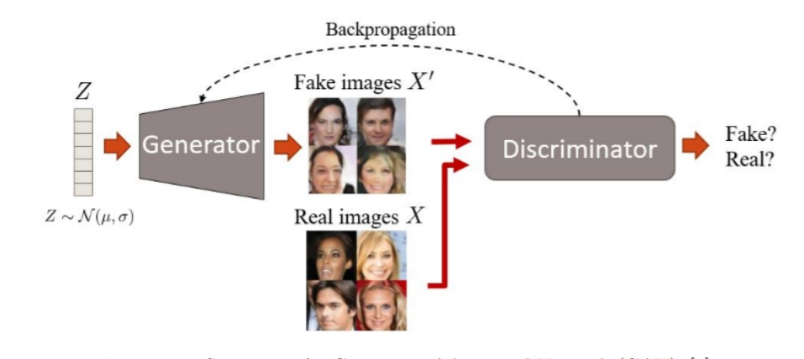This chapter reviews basic concepts to understand the foundations of Generative Adversarial Network (GAN) which is a generative modelling architecture introduced. GANs was introduced by Goodfellow in 2014. Generative Adversarial Networks (GANs) have recently demonstrated to successfully approximate complex data distributions. This allows, for example, to generate visually appealing images. The working principle of GAN is rooted in game theory. At a high level, a GAN works by staging a battle between Generator and Discriminator networks. The task of the discriminator is to discriminate between the generated data and the original data. The task of the generator is to fool the discriminator by generating

Figure 1.2: Structure of a Generative Adversarial Network (GAN)

data which looks like real data. GANs have been able to successfully approximate high dimensional data.

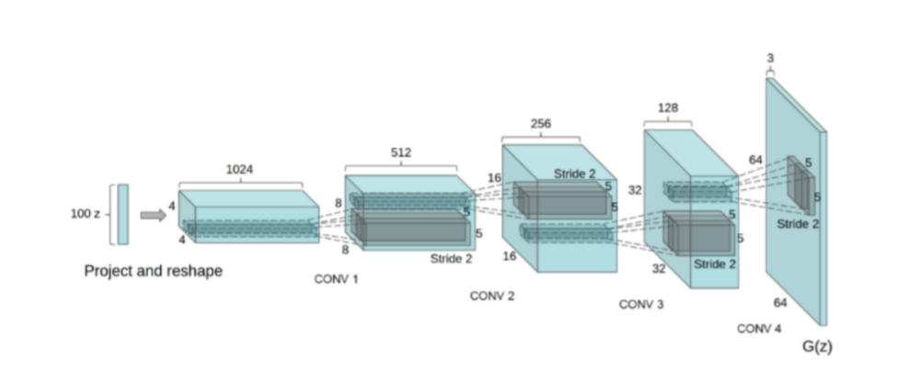 Mathematically GANs is composed of two neural networks, a generator G and a discriminator D. In order to train both the networks we need data X so we are able to generate fake data X0 with the generator G. More precisely, X is sampled from the true and unknown data distribution pdata (e.g., face images) and X0 from the generator distribution pg (sampling with G). The goal is to accurately approximate pg to pdata; ideally, we want pdata = pg. There is a third known distribution z ∼ pz (e.g., a normal distribution) which is used as an input for the generator G(z).

Figure 1.3: Generator network in GANs.

Generator G takes a noise vector z as input and generates samples X0. Discriminator network D gets samples from both the generated and the training data. Generator network G tries to produce more and more realistic samples, and the discriminator tries to get better and better at distinguishing between generated data from real data. Generator and discriminator are trained alternatively, which means a gradient step firstly is taken for generator, then a step is taken for discriminator.

Figure 1.4: Discriminator network in GANs.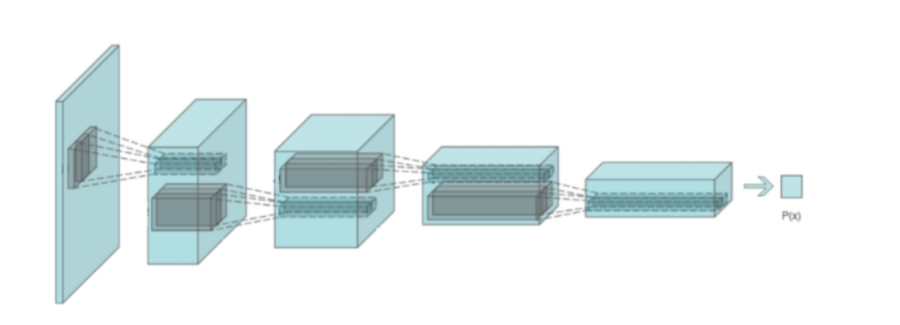

There have been more than 200 improvements of GANs published since 2014. One of the improvements was Deep Convolutional GANs (DCGANs). They are made of standard convolutional neural network components, such as convolutional layers and transposed convolutional layers. They incorporated Batch Normalization which led to achieving stable training and promising results. Another relevant extension of the GAN model is ’conditional GANs’ (cGANs). cGANs have an extra input Y that conditions the generated image by feeding Y into both discriminator and generator. This thesis combines the Autoencoder and GANs in a hybrid fashion to anonymize faces. Also, Makhzani proposed a similar idea by combining a VAE with a GAN with promising results.

To implement our idea, we use a multi-task extension of the generative adversarial network (GAN) formulation. Our face anonymizer serves as the generator and modifies the face pixels in video frames to minimize face identification accuracy. Our face identifier serves as the discriminator, and tries to maximize face identification accuracy in spite of the modifications. The activity detection model serves as another component to favour modifications that lead to maximal activity detection. We experimentally confirm the benefits of our approach for privacy-preserving action detection on the datasets compared to conventional hand-crafted anonymization methods including masking, blurring, and noise adding. Finally, although outside the scope of this work, the idea is that once we have the learned anonymizer, we could apply it to various applications including surveillance, smart-home cameras, and robots, by designing an embedded chipset responsible for the anonymization at the hardware-level. This would allow the images/videos to lose the identity information before they get loaded to the processors or sent to the network for recognition.

**CHAPTER-2**

# BACKGROUND STUDY

**2.1 Literature Survey**

In the literature, privacy preservation in face images has been studied from two perspectives. Researchers have studied this problem in terms of privacy-preserving biometrics while others have termed it as attribute suppression. ace images reveal a lot of ancillary information for which the user may not have consented. In order to protect such ancillary information (soft biometrics), researchers have proposed several different methodologies.

In 2000, Boyle developed an algorithm to blur and pixelate the images in the video. In 2005, Newton have developed an algorithm for face de-identification in video surveillance such that the face recognition fails while preserving other facial details. In 2006, Gross have shown that distorting image via blurring and pixelation method gives poor results. To improve the results, they proposed model-based face de-identification method for privacy protection. Some researchers have also worked on the privacy of soft biometrics. In 2014, Othman and Ross have proposed attribute privacy preserving technique, in which the soft biometrics attribute such as gender is “flipped” while preserving the identity for face recognition. In order to flip the gender, face morphing scheme is used in which the face of other opposite gender is morphed with the input image. As an extension of this work, Mirjalili and Ross have proposed Delaunay triangulation, and convolutional autoencoders based methods to flip gender information while preserving face identity in 2017.

In 2011, Suo have presented an image fusion framework in which the template of opposite gender face image is taken for fusion with the candidate image while preserving face identity. In 2015, Jourabloo have developed an algorithm for de-identification of face image while preserving other attributes. For attribute preservation, it uses k images (motivated by k-Same) which shares the same attributes for fusion. In 2015, Sim and Zhang have proposed a method which independently controls the identity alteration and preserves the other facial attributes. It decomposes the facial attribute information into different subspaces to independently control these attributes. To anonymize the facial attributes, Rozsa have proposed deep learning-based model for facial attribute prediction in 2017. A deep convolutional neural network is trained for each attribute separately and in order to test the robustness of the trained model, adversarial images are generated using fast flipping attribute (FFA) technique. As an extension of their work Rozsa have used FFA and adversarial images are generated in which a facial attribute is flipped in 2016. They have observed that the few attributes are affected while flipping the targeted attribute. For instance, while changing the ‘wearing lipstick’ attribute, other attributes such as ‘attractive’ and ‘heavy makeup’ are also flipped. Based on the literature review, we observe that there are algorithms for single attribute anonymization. However, there are three major challenges in anonymizing multiple attributes.

1. While anonymizing facial attributes, there should be no visual difference between original and anonymized images.
2. Selectively anonymizing few and retaining some attributes require a “control” mechanism. For example, gender and expression can be anonymized while retaining race and eye colour and other attributes such as attractiveness and hair colour may be in “do not care” condition.
3. In applications involving matching faces for recognition, identity should be preserved while anonymizing attributes.

The major limitation of these methods is that they do not address the first two challenges mentioned above. Existing algorithms primarily depend on a candidate image which is fused with the original image. This privacy preserving fusion leads to major transform and loss in visual appearance. Rozsa have addressed this issue but due to lack of any control mechanism, the other attributes are also suppressed, while suppressing one attribute.

**2.2 Deep Learning**

Deep learning has impacted all areas of machine learning and data science. A large amount of deep learning related papers has been published if one observes the recent papers in the relevant arXiv categories. No doubt deep learning has become a very popular and strong research topic in recent years. More specifically supervised learning has demonstrated better-than-human performance for discriminative focused tasks. Implemented with artificial neural networks (NN) and using huge amounts of data, these models use a series of non-linear operations that helps construct a decision boundary. This decision boundary can enable a model to classify an image among 100-1000 categories or decide when should a car stop to prevent a collision. But in order to achieve the state-of-the-art performance a neural network requires a huge amount of ’labelled’ data for training, which, in some cases, could represent a very tough task. A successful and efficient alternative to overcome this problem is to use unsupervised learning methods.

Deep learning is a collection of advanced algorithms having multiple layers, composed of multiple linear and non-linear transformations. The earliest deep learning architecture was composed of multiple layers of non-linear features and it had polynomial activation functions. It was proposed by Ivaknenko and Lapa in 1965. In 1980, Fukushima proposed the Convolutional Neural Networks (CNN), which has multiple pooling and convolution layers. CNN performs better compared to the traditional image processing algorithms because unlike traditional image processing algorithms, CNN doesn’t involve a time-consuming process of manual feature extraction which also requires expert knowledge.

**2.3 Neural Network**

A standard neural network (NN) consists of multiple simple, connected processors called neurons, each producing a sequence of real-valued activations. Input neurons get activated through sensors perceiving the environment like camera looking at road images, other neurons get activated through weighted connections from previously active neurons. Some neurons may influence the environment by triggering actions. Learning is basically credit assignment i.e., finding weights that make the NN behave desirably, such as accelerating/braking a car. Thus, Deep Learning is about accurately finding weights that solves the desired problem. In the following section we will discuss various kinds of layers that are used in all the success-full neural networks

**2.3.1 Layers**

**Fully Connected Layer**

Neurons in a fully-connected layer have full connections to all activations in the previous layer, which means every neuron in the previous layer is connected to every neuron in the next layer. The output from the convolution and pooling layers is a low dimensional representation of high dimensional input image. In a classification problem, the fully connected layer can use this low dimension representation to classify the input image into various classes. Mathematically, fully connected layer can be thought of as a function which applies a linear transformation on a vectorial input of dimension I to give an output vector of dimension O. Usually the layer also has an additional parameter called bias parameter.

y = A ∗ x + b

yi = X I j=1 (Ai,jxi) + bi

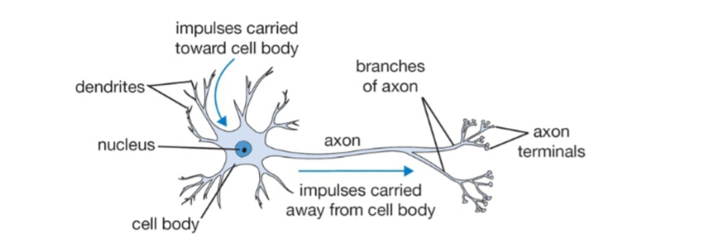The linear layer is inspired by the basic computational unit of the brain called neuron. Human nervous system consists of approximately 86 billion neurons and they are connected with approximately 1014 - 1015 synapses.

Figure 2.1: A biological neuron.

Each neuron receives input signals from its dendrites and produces output signal along its axon. The linear layer is a simplified version of a group of neurons having their dendrites connected to the same inputs. Usually an activation function f, such as sigmoid is used to mimic the 1-0 impulse carried away from the cell body and also to add non linearity.

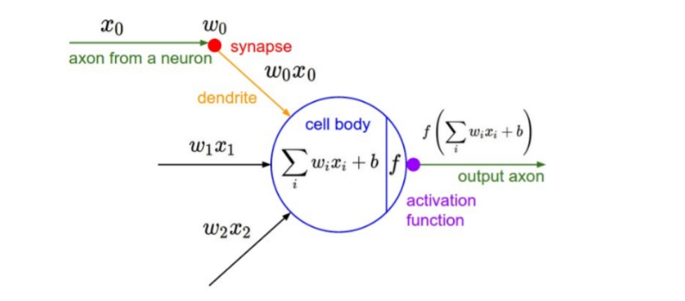

Figure 2.2: Mathematical model of a neuron.

**Activation Layer**

Activation layer is used to introduce non-linearity into the network. This gives neural network the capacity of approximating any function. There are four main activation functions: Sigmoid, Tanh, ReLU and Leaky ReLU. Sigmoid and Tanh are often used in the fully-connected layer. ReLU and Leaky ReLU are often used in the convolutional layer.

All the activation functions take a vector and performs a certain fixed point-wise operation on it. Following are the commonly used activation functions:

**Sigmoid** The Sigmoid non-linearity has the following mathematical form:

y = σ(x) = 1/ (1 + e −x)

A sigmoid function produces a curve with an S shape. It takes a real value and squashes it between 0 and 1. When the neurons activation saturates at either tail of 0 or 1, the gradient at these regions becomes almost zero. Therefore, the neural network using sigmoid as the activation function suffers from the vanishing gradient problem during gradient-based training. Due to the vanishing gradient problem, the gradient value in the front layers of networks decreases greatly, which makes the preceding layer train very slowly. Thus, the back propagation algorithm fails at modifying its parameters and the parameters of the preceding neural layers.

Figure 2.3: Sigmoid non-linearity.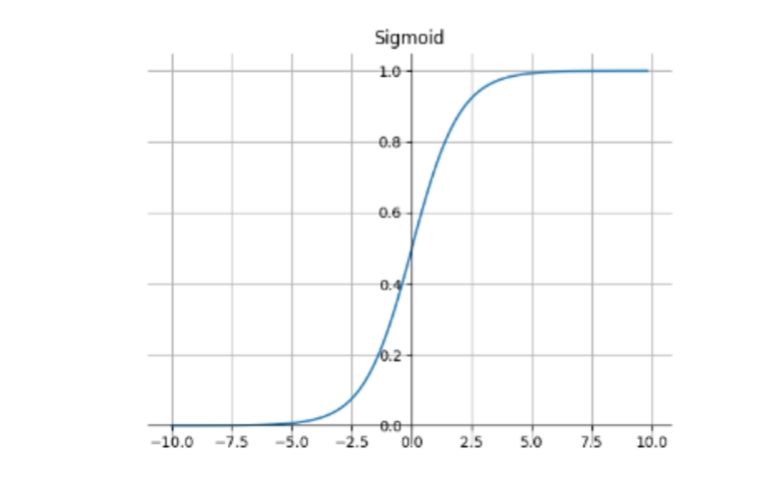

**Hyperbolic Tangent**

The tanh(x) function can be seen as a rescaled version of the sigmoid, and its output falls in the interval of (1, 1). The TanH non-linearity has the following mathematical form:

y = 2σ(2x) − 1

However, it has the same drawback as the sigmoid function.

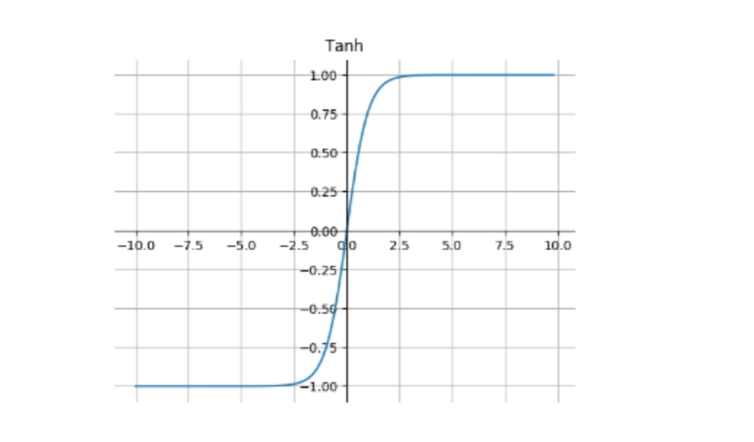

Figure 2.4: Tanh non-linearity.

**Rectified Linear Unit**

The Rectified Linear Unit (ReLU) has become very popular in the last few years, because it was found to greatly accelerate the convergence of stochastic gradient descent compared to the sigmoid and tanh functions due to its linear non-saturating form. Therefore, ReLU greatly shortens the learning cycle. And the use of ReLU introduces the sparsity.

The ReLU has the following mathematical form

y = max (0, x)

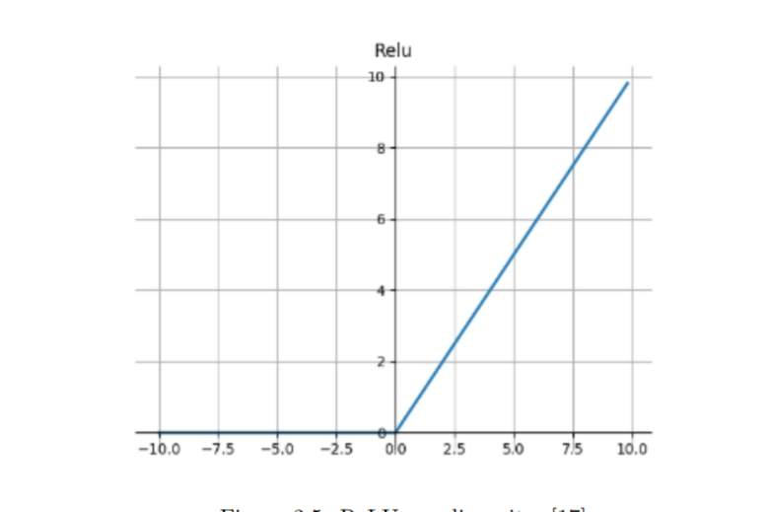 It has been shown that ReLU has faster training speed compared to Sigmoid and Tanh. And it does not suffer from the vanishing or exploding gradient problems. Another advantage is that it involves cheap operations compared to the exponentials which are relatively expensive. But, the ReLU removes all the negative informations and has zero gradient for negative values which leads to ’dying ReLU’ problem. Therefore, it is not suitable for all datasets and architectures.

Figure 2.5: ReLU non-linearity.

**Leaky ReLU**

Leaky ReLU is an improvisation to ReLU which tries to fix the ’dying ReLU’ problem. Instead of the function being zero when x < 0, it has a small positive gradient for negative inputs. Leaky ReLU has the following mathematical form:

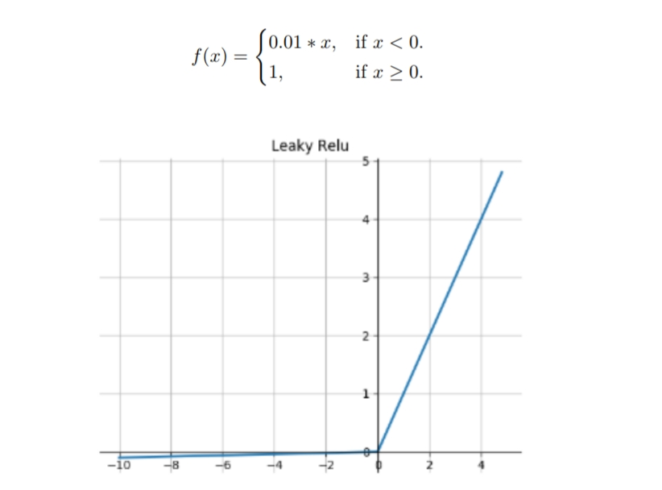

Figure 2.6: Leaky ReLU non-linearity.

**Spatial Convolution**

Regular neural networks which are only composed of linear and activation layers, do not work well for full images because of high dimensionality of image data. For instance, images of size 3×256×256 (3 color channels, 256 wide, 256 high) would necessitate a first linear layer having 3×256×256 + 1 = 196,609 parameters for a single neuron. Images have spatial relationship and ’Spatial convolution’ layer takes advantage of this fact. In fact, neighboring pixels should not be affected by their location within image. Thus, a ’Spatial Convolution’ layer learns a set of Nk filters F = f1, ..., fNk, which are convolved spatially with input image x, to produce a set of Nk 2D features maps z: zk = fk ∗ x where ∗ is the convolution operator. When the filter matches well with a region of the input image, the response in the corresponding feature map location is strong. Weights for each filter are shared over the entire image reducing the number of parameters per feature map and equivariance is learned (i.e., an object shifted in the input image will simply shift the corresponding responses in a similar way). This is not the case with conventional fully connected linear layer. A fully connected layer can be seen as a convolutional layer with filter of sizes 1×1×inputSize. It is important to highlight that a ’spatial convolution’ layer is not defined by the spatial size of the input feature maps (e.g., width and hight), neither by the size of the output feature maps, but by the number

of filters (e.g., number of output channels), the properties of its filters (e.g., number of input 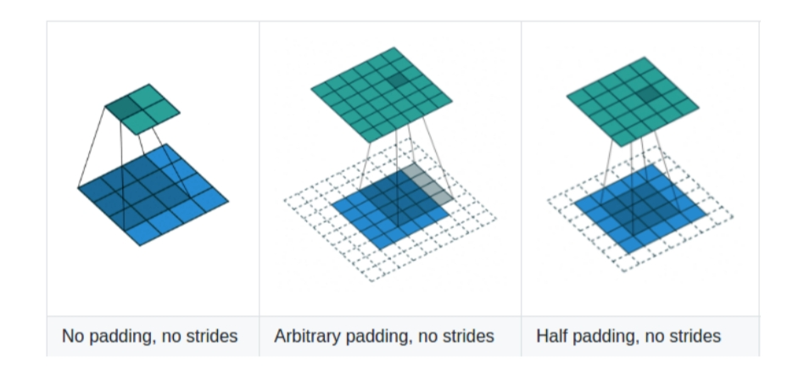channels, width and height) and the properties of the convolution (e.g., padding, stride).

Figure 2.7: Convolution mechanism with Input (Blue Matrix) and Output (Green Matrix), Filter size from left to right (3X3),(4X4) and (3X3).

**Spatial Pooling**

Pooling layers does the operation of reducing the size of the feature maps and this also helps achieve invariance to slightly different input images. Pooling works by sliding a window across the input ’feature maps’.

It uses pooling functions, such as Max-Pooling and Average-Pooling, to calculate the sampling value of the elements in the pooling window.

* Max-Pooling: Picks the largest element from the pooling window.
* 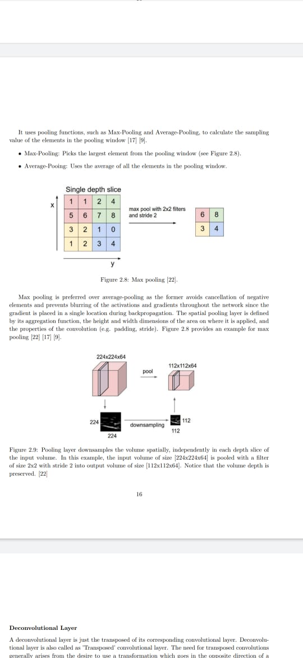Average-Pooing: Uses the average of all the elements in the pooling window

Figure 2.8: Max pooling

Max pooling is preferred over average-pooling as the former avoids cancellation of negative elements and prevents blurring of the activations and gradients throughout the network since the gradient is placed in a single location during backpropagation. The spatial pooling layer is defined by its aggregation function, the height and width dimensions of the area on where it is applied, and the properties of the convolution (e.g., padding, stride).



Figure 2.9: Pooling layer down samples the volume spatially, independently in each depth slice of the input volume. In this example, the input volume of size [224x224x64] is pooled with a filter of size 2x2 with stride 2 into output volume of size [112x112x64]. Notice that the volume depth is preserved.

**Deconvolutional Layer**

A deconvolutional layer is just the transposed of its corresponding convolutional layer. Deconvolutional layer is also called as ’Transposed’ convolutional layer. The need for transposed convolutions generally arises from the desire to use a transformation which goes in the opposite direction of a normal convolution i.e., to project feature maps to a higher-dimensional. For example, mapping a 4-dimensional space to a 25-dimensional space while keeping the connectivity pattern of the convolution.

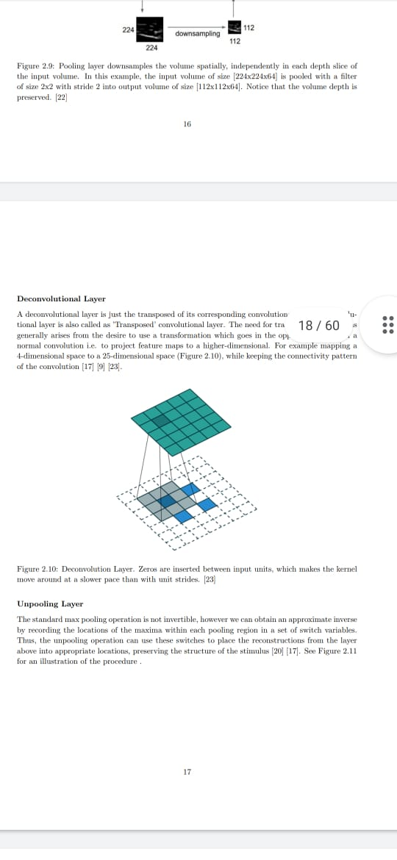

Figure 2.10: Deconvolution Layer. Zeros are inserted between input units, which makes the kernel move around at a slower pace than with unit strides.

**Unpooling Layer**

The standard max pooling operation is not invertible; however, we can obtain an approximate inverse by recording the locations of the maxima within each pooling region in a set of switch variables. Thus, the unpooling operation can use these switches to place the reconstructions from the layer above into appropriate locations, preserving the structure of the stimulus.

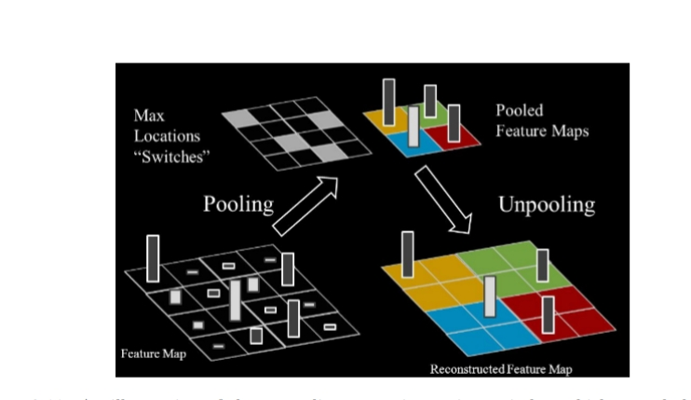

Figure 2.11: An illustration of the unpooling operation, using switches which record the location of the local max in each pooling region (colored zones) during pooling operation.

**Batch Normalization**

Training ’Deep Neural Networks’ is complicated because the distribution of each layer’s inputs changes during training, as the parameters of the previous layers change. This slows down the training by requiring lower learning rates and careful parameter initialization, and makes it very hard to train models with saturating non-linearities. This problem was addressed by using ’Batch Normalization’ layer.

Batch Normalization layer became very popular due to its ability to make neural network converge faster and also help NN achieve higher overall accuracy. It transforms the inputs to zero-mean and unit variance, which makes the inputs of each trainable layer comparable across features.

Batch Normalization allows activation functions such as TanH and Sigmoid to not get stuck in the saturation mode (e.g., gradient equal to 0). It allows to use much higher learning rates and be less careful about initialization. It also acts as a ’regularizer’. Batch Normalization reduces training time by 14 times when applied to a state-of-the-art image classification model. Thus, it beats the original models by a significant margin.

**2.3.2 Neural Network Architectures**

Using a set of layers can define a neural network architecture. In this section most common and successful neural network architectures are discussed.

**Convolutional Neural Network (CNN)**

A Convolutional Neural Network (CNN, or ConvNet) is a class of deep, feed-forward artificial neural networks that has successfully been applied to analyzing images. In a CNN the unit connectivity pattern is inspired by the organization of the visual cortex. Units respond to stimuli in a restricted region of space known as the receptive field. The receptive fields of different neurons partially overlap such that they cover the entire visual field. Unit response can be approximated mathematically by a convolution operation.

CNNs are built using three main types of layers: Convolutional Layer, Pooling Layer, and Fully Connected Layer. They are also known as shift invariant or space invariant artificial neural networks (SIANN), based on their shared-weights architecture and translation invariance characteristics.

CNNs are better than classical image classification algorithms as they use relatively little preprocessing. This means that the network learns the filters that in classical algorithms were manually designed. Therefore, the major advantage of CNN is its independence from prior knowledge and human effort in feature design. They have applications in image and video recognition, recommendation systems and natural language processing.

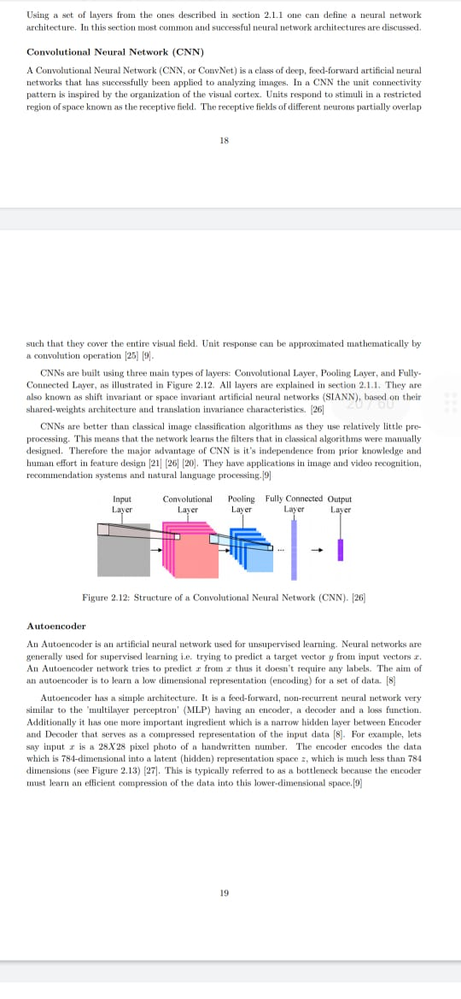

Figure 2.12: Structure of a Convolutional Neural Network (CNN).

**Autoencoder**

An Autoencoder is an artificial neural network used for unsupervised learning. Neural networks are generally used for supervised learning i.e., trying to predict a target vector y from input vectors x. An Autoencoder network tries to predict x from x thus it doesn’t require any labels. The aim of an autoencoder is to learn a low dimensional representation (encoding) for a set of data.

Autoencoder has a simple architecture. It is a feed-forward, non-recurrent neural network very similar to the ’multilayer perceptron’ (MLP) having an encoder, a decoder and a loss function. Additionally, it has one more important ingredient which is a narrow-hidden layer between Encoder and Decoder that serves as a compressed representation of the input data. For example, let’s say input x is a 28X28 pixel photo of a handwritten number. The encoder encodes the data which is 784-dimensional into a latent (hidden) representation space z, which is much less than 784 dimensions. This is typically referred to as a bottleneck because the encoder must learn an efficient compression of the data into this lower-dimensional space.

Thus, an Autoencoder is a neural network capable of unsupervised feature learning. Recently, autoencoder has been used extensively for image generation task also.

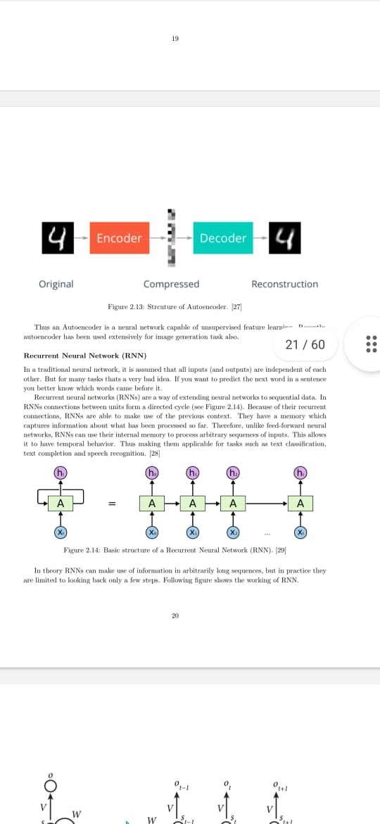

Figure 2.13: Structure of Autoencoder.

**Recurrent Neural Network (RNN)**

In a traditional neural network, it is assumed that all inputs (and outputs) are independent of each other. But for many tasks that’s a very bad idea. If you want to predict the next word in a sentence you better know which words came before it.

Recurrent neural networks (RNNs) are a way of extending neural networks to sequential data. In RNNs connections between units form a directed cycle. Because of their recurrent connections, RNNs are able to make use of the previous context. They have a memory which captures information about what has been processed so far. Therefore, unlike feed-forward neural networks, RNNs can use their internal memory to process arbitrary sequences of inputs. This allows it to have temporal behaviour. Thus, making them applicable for tasks such as text classification, text completion and speech recognition.



Figure 2.14: Basic structure of a Recurrent Neural Network (RNN).

In theory RNNs can make use of information in arbitrarily long sequences, but in practice they are limited to looking back only a few steps. Following figure shows the working of RNN.

Figure 2.15: Working of a Recurrent Neural Network (RNN).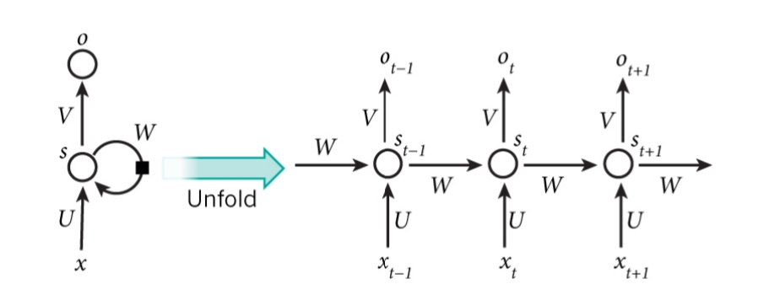

**2.4 Generative Adversarial Network (GAN)**

Generative Adversarial Networks (GANs) are a class of artificial intelligence algorithms used in unsupervised machine learning, implemented by a system of two neural networks contesting against each other in a zero-sum game framework. They were introduced by Ian Goodfellow in 2014.

This technique can generate photographs that look realistic to human observers. For example, GANs can be used to generate a synthetic photograph of a dog that fools the discriminator into accepting it as an actual photograph.

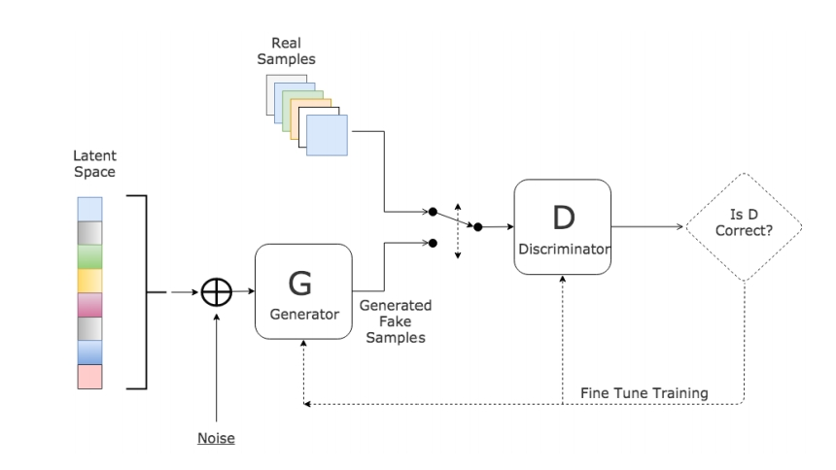

Figure 2.16: The structure of a Generative Adversarial Network (GAN)

Generative Adversarial Networks consist of a pair of models called the generator and discriminator. The generative models can be thought of as a group of thieves trying to generate counterfeit currency whereas the discriminative model can be thought of as police trying to detect the counterfeit currency. Thus, the entire framework resembles a two-player minimax game where the generator tries minimize its objective function and the discriminator tries to maximize its objective function. The objective of this game is given as follows:

min G max D V (D, G) = Ey∼prealF aces(y) [logD(y)] + Ex∼pinputF aces(x) [log (1 − D(G(x)))]

**2.4.1 Different Versions of Generative Adversarial Networks**

**Conditional Generative Adversarial Networks**

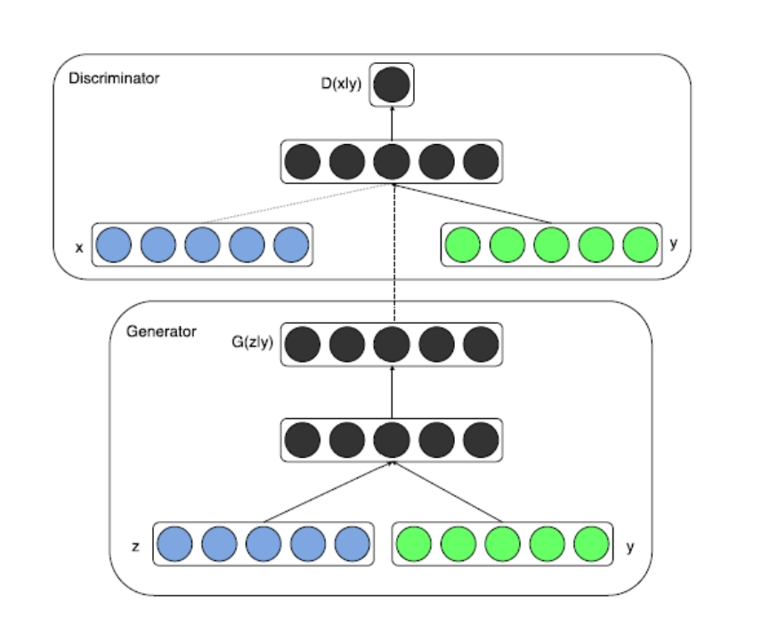

Figure 2.17: The structure of a Conditional Generative Adversarial Network (CGAN)

Conditional Generative Adversarial Networks (CGANs) (Mirza & Osindero, 2014) are the conditional version of GANs which are constructed by feeding the data y, we want to condition on the generator and discriminator. Here y can be any kind of information such as class labels or data from other modalities. In the generator for CGANs, the prior input noise pz(z) and the auxiliary information y are combined in joint hidden representations. In the discriminator, x and y are presented as inputs to the discriminative function. Here, the objective function is similar to that of vanilla GAN except that the data distributions are now conditioned on y. This modified objective function is given as follows:

min G max D V (D, G) = Ey∼prealF aces(y) [logD(y)] + Ex∼pinputF aces(x) [log (1 − D(G(x)))]

Both, the generator and the discriminator are multilayer perceptrons with Rectified Linear Units (ReLU) as the activation for hidden layers and sigmoid for the output layer. The model is trained using stochastic gradient descent with initial learning rate of 0.1 exponentially decreased down to .000001 with a decay factor of 1.00004. Mirza also demonstrate the use of CGANs for automated tagging of images with multi-label predictions. This allows them to generate a distribution of tag-vectors conditional on image features.

**Laplacian Pyramid of Adversarial Networks**

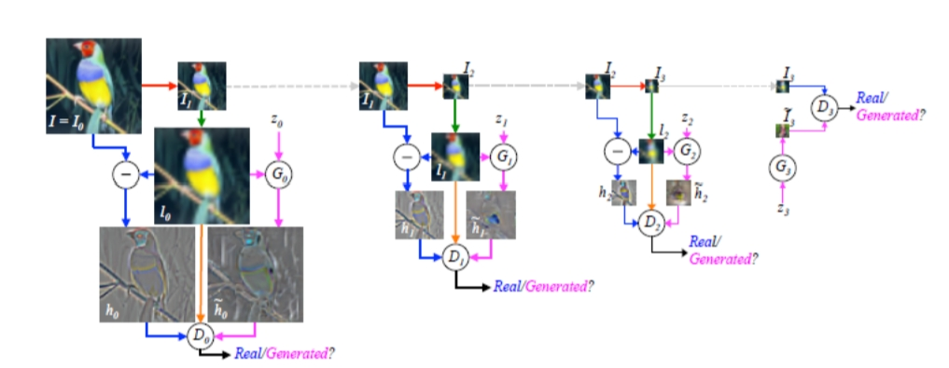

Figure 2.18: The structure of a Laplacian Pyramid of Generative Adversarial Network (LAPGAN)

Denton proposed the generation of images in a coarse-to-fine fashion using cascade of convolutional networks within a Laplacian pyramid framework. This approach allowed them to exploit the multiscale structure of natural images, building a series of generative models, each capturing image structure at a particular level of the Laplacian pyramid. The Laplacian pyramid is built from a Gaussian pyramid using upsampling u(.) and downsampling d(.) functions. Let G(I) = [I0, I1, ..., IK] be the Gaussian pyramid where I0 = I and IK is k repeated applications of d(.) to I. Then, the coefficient hk at level k of the Laplacian pyramid is given by the difference between the adjacent levels in Gaussian pyramid, upsampling the smaller one with u(.).

hk = Lk(I) = Gk(I) − u(Gk+1(I) = Ik − u(Ik+1))

LAPGANs also take advantage of the CGAN model by adding a low-pass image lk to the generator as well as the discriminator. The authors evaluated the performance of the LAPGAN model on three datasets: (i)CIFAR10 (ii)STL10 and (iii) LSUN datasets. This evaluation was done by comparing the log-likelihood, quality of image samples generated and a human evaluation of the samples.

**Deep Convolutional Generative Adversarial Networks**

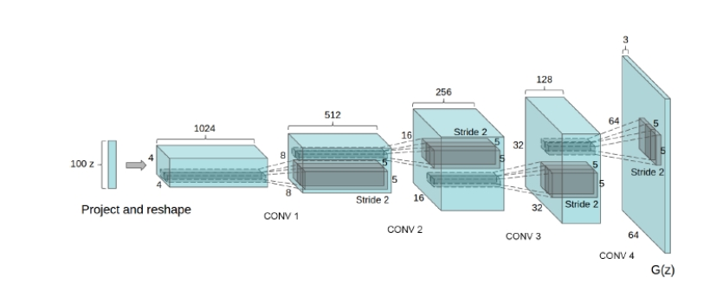

Figure 2.19: The structure of a Deep Convolutional Generative Adversarial Network (DCGAN)

Radford proposed a new class of CNNs called Deep Convolutional Generative Adversarial Networks (DCGANs) having certain architectural constraints. These constraints involved adopting and modifying three changes to the CNN architectures.

* Removing fully-connected hidden layers and replacing the pooling layers with strided convolutions on the discriminator and fractional-strided convolutions on the generator
* Using batch normalization on both the generative and discriminative models
* Using ReLU activations in every layer of the generative model except the last layer and LeakyReLU activations in all layers of the discriminative model

The quality of unsupervised representation learning was evaluated by first using DCGAN as a feature extractor and then the performance accuracy was calculated by fitting a linear model on top of those features. Log-likelihood metrics were not used for performance evaluation. The authors also demonstrated feature learning by the generator showcasing how the generator could learn to forget scene components such as bed, windows, lamps and other furniture. They also performed vector arithmetic on face samples leading to good results.

**Adversarial Autoencoders**

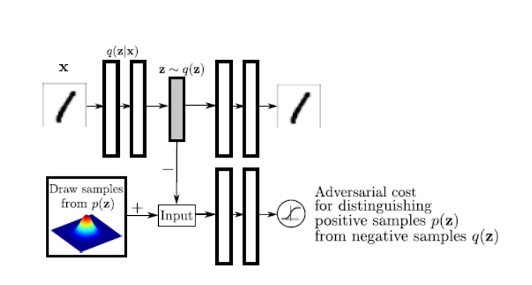

Figure 2.20: The structure of an Adversarial Autoencoder (AAE)

Makhzani proposed adversarial autoencoder which is a probabilistic autoencoder which makes use of GAN to perform variational inference by matching the aggregated posterior of the hidden code vector of the autoencoder with an arbitrary prior distribution. In adversarial autoencoder, the autoencoder is trained with dual objectives - a traditional reconstruction error criteria, and an adversarial training criterion that matches the aggregated posterior distribution of the latent representation to an arbitrary prior distribution. After training, the encoder learns to convert the data distribution to the prior distribution, while the decoder learns a deep generative model that maps the imposed prior to the data distribution.

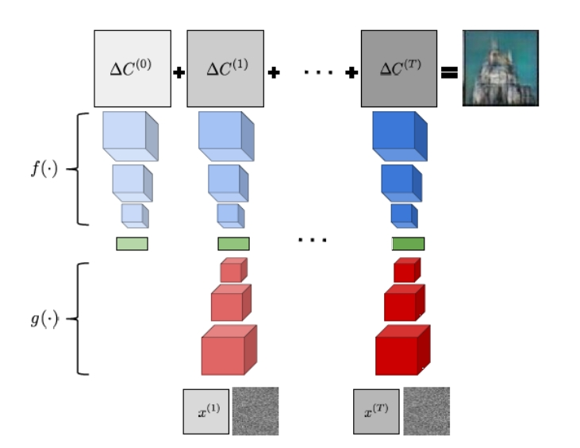**Generative Recurrent Adversarial Networks**

Figure 2.21: The structure of a Generative Recurrent Adversarial Network (GRAN)

Im proposed recurrent generative model showing that unrolling the gradient-based optimization yields a recurrent computation that creates images by incrementally adding to a visual “canvas”. Here, the “encoder” convolutional network extracts images of current “canvas”. The resulting code and the code for the reference image get fed to a “decoder” which decides on an update to the “canvas”. Figure 6 depicts an abstraction of how a Generative Recurrent Adversarial Network works. The function f serves as the decoder and the function gserves as encoder in GRAN.

**Information Maximizing Generative Adversarial Networks**

Information maximizing GANs (InfoGANs) are an information-theoretic extension of GANs that are able to learn disentangled features in a completely unsupervised manner. A disentangled representation is one which explicitly represents the salient features of a data instance and can be useful for tasks such as face recognition and object recognition. Here, InfoGANs modify the objective of GANs to learn meaningful representations by maximizing the mutual information between a fixed small subset of GAN’s noise variables and observations.

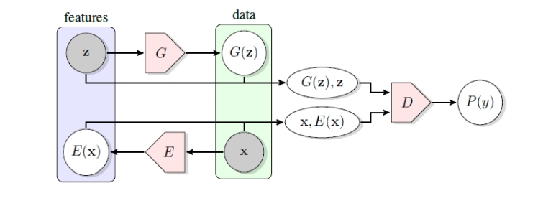**Bidirectional Generative Adversarial Networks**

Figure 2.22: The structure of a Bidirectional Generative Adversarial Network (BiGAN)

Donahue proposed a method for learning the semantics in data distribution as well as its inverse mapping - using these learnt feature representations for projecting data back into the latent space. As it can be seen from the figure, in addition to the generator G from the standard GAN framework, BiGAN includes an encoder E which maps the data x to latent representations z. The BiGAN discriminator D discriminates not only in the data space (x versus G(z)), but jointly in data and latent spaces (tuples (x, E(x)) versus (G(z), z)), where the latent component is either the encoder output E(x) or generator input z. Here, according to the objective of GANs, the BiGAN encoder E should learn to invert the generator G.

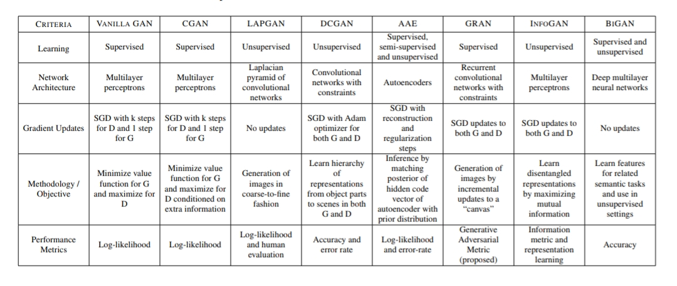

Table 1. Comparison of different versions of GANs based on various criteria.

**CHAPTER-3**

# PROPOSED WORK

**3.1 Anonymizer Architecture**

GAN Anonymizer is composed of three important parts (generator, discriminator and multiple loss functions) that serve distinct purposes. Similar to traditional GANs, we have two sub-networks: a generator sub-network G and a discriminator sub network D. Unlike traditional GANs the generator sub network G in our case is a symmetric neural network consisting of encoder and decoder. Its primary goal is to synthesize a full-face image from an image of a face in which most important parts have been deleted. The discriminator sub-network D serves to distinguish the fake face image synthesized by the generators from corresponding ground truth real image. Basically, Discriminator D is used to formulate adversarial loss. It can also be viewed as a guidance for the generator G. Additionally we have added another loss function whose job is to make sure that created face keeps the ’context’ from the input face. Context includes skin colour, hair-style, age and background etc. This loss function is named as ’Recreation Loss’ because it tries to recreate the context of the original face. Additionally, this recreation loss function ensures that the generated face images are visually appealing as GANs tend to create images with artifacts due to multi-modal data distribution.

**3.2 Generator Network: Encoder and Decoder**

The overall architecture is a simple encoder-decoder. The encoder takes an input face image with missing regions and produces a latent feature representation of that image. The decoder takes this feature representation and produces the missing image content.

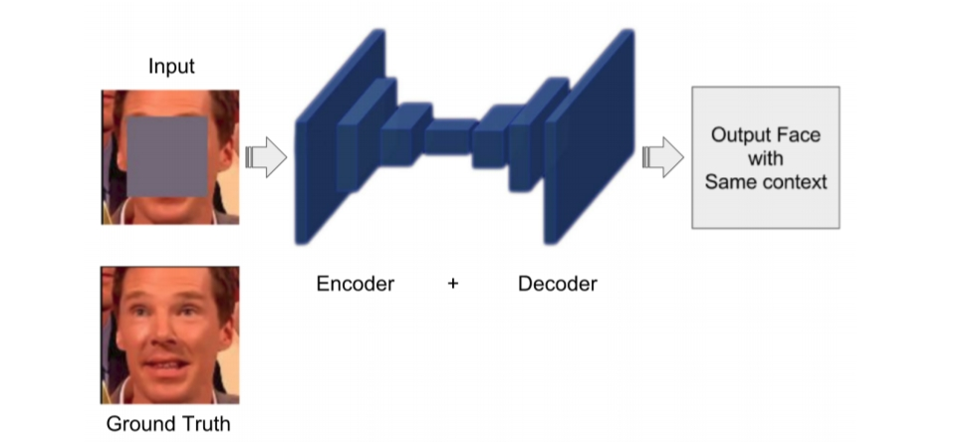

Figure 3.1: Suggested architecture for Generator.

**Encoder:** Our encoder is composed of 7 modules. Each module (CBR) contains convolutional layer, batch-normalisation layer and leaky relU as non-linearity. Every convolutional layer has a kernel of 4 × 4 and stride 2 × 2 (Given an input image of size 256 × 256 it computes compute an abstract 1 × 1 × 4000-dimensional feature representation which is then fed to decoder. Fully connecting the encoder and decoder would result in an explosion in the number of parameters which will make training impossible therefore compressed representation is used.

**Decoder**: Decoder is symmetric to encoder. The decoder network consists of similar modules just like the encoder network, only difference being the deconvolution layers instead of convolution layers. The purpose of the decoder is to decode the information i.e., to generate pixels of the face image using the features from encoder. A deconvolutional layer, is simply a transposed convolutional layer or up sampling layer that projects feature maps to a higher dimensional space. Eventually, the series of up-convolutions and non-linearities leads to up sampling of the feature produced by the encoder until we reach the original target size of the image.

**3.3 Objective Function**

Typically, an objective function is a loss function or negative of loss function which is used for parameter estimation. It is some function of the difference between estimated and true values for an instance of data. Various experiments were performed so as to choose the best possible objective function for the task in hand. A joint loss has been suggested which has following two parts:

* Recreation loss.
* Adversarial loss.

**3.3.1 Recreation Loss**

The task in hand requires us to anonymize the faces keeping the context in the output image same as the input image. For keeping the context of output and input images same we needed a similarity function which would help us achieve this task. Let us name this function as ’Recreation loss’ which will use similarity functions like L1 or L2 norm to compare output and input images. The whole idea of Recreation loss is to re-create the context from the input image. Additionally, a mask is applied to compare the output and original image. As we want to anonymize the output image therefore, we do not compare the ’identity zone’ of the output and original image therefore we multiply a mask, which contains zeros in the ’identity zone’, to the difference of output and original images. Thus, a mask prevents matching of the ’identity zone’ (eyes, nose, lips etc) for output and original image.

Lrec = ||M.(y − G(x))||1or2

* x denotes input image.
* G(x) denotes anonymized image.
* y denotes original image.
* M denotes a mask with zeros in identity zone

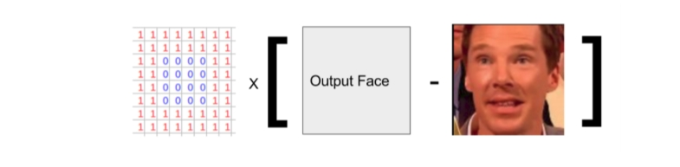

Figure 3.2: Recreation loss: Masked Loss function

As already mentioned, one can use L1 or L2 distance to compare the images.

**L2 norm** L2-norm or L2-loss function is also known as least squares error (LSE). It is basically minimizing the sum of the square of the differences (S) between the target value (yi) and the estimated values (f(xi)):

S = ||y − F(x)||2

The above equation can be simplified as:

S = Xn i=1 (yi − f(xi))2

**L1 Loss** L1-norm or L1-loss function is also known as least absolute deviation (LAD) or least absolute error (LAE). It is basically minimizing the sum of the absolute differences (S) between the target value (yi) and the estimated values (f(xi)):

S = Xn i=1 |yi − f(xi)|

L1 loss has applications in many areas because it is robust compared to L2 loss. Unlike L2 loss, L1 loss is not very sensitive to outliers in the data. So, if an application requires attention to outliers, then L2 loss becomes a preferred choice and L1 loss is preferred when outliers can be ignored safely.

**3.3.2 Adversarial Loss**

The adversarial loss is based on Generative Adversarial Networks (GANs). This is used to train the Generator (G) and Discriminator network (D). The learning procedure is a two-player game where an adversarial discriminator D takes in both the output faces from G and ground truth faces, and tries to distinguish them, while G tries to generate real looking faces to confuse D. The objective for discriminator is logistic likelihood indicating whether the input is real or fake. Adversarial loss is of the following form:

min G max D V (D, G) = Ey∼prealF aces(y) [logD(y)] + Ex∼pinputF aces(x) [log (1 − D(G(x)))]

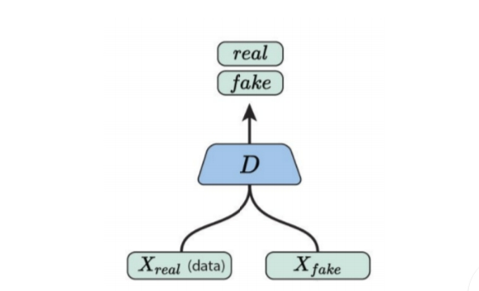GANs (adversarial loss) has shown fantastic results in generative modelling 3 of images thus we have adapted this loss function for face anonymizer. Adversarial loss makes sure that the faces produced by face anonymizer looks as close to real faces as possible. Face images can have artifacts due to ’Adversarial loss’ but ’Recreation loss’ function ensures that the generated face images are smooth.

Figure 3.3: Discriminator for Adversarial loss

Thus ’joint loss’ (objective function) encourages the entire output of the face anonymizer to look realistic keeping the context of output and input similar.

**3.4 Suggested Algorithm for Data Preparation**

Once the neural network architecture and objective function is finalized the next main task is to collect face data for NN training. More than 200k images of people (not just cropped faces) were downloaded from various databases like ’CelebA’ database etc. Each image could contain multiple people therefore multiple faces. After collecting ’people photos’ a pre-trained face detector neural network was used to crop square faces.

**3.4.1 Iteration 1: Using existing database**

The data preparation was simple during the first iteration. ’CelebA’ dataset was used during the initial phase. ’CelebA’ is a large-scale face attributes dataset with more than 200K celebrity images, each with 40 attribute annotations. The images in this dataset cover large pose variations and background clutter. CelebA has large diversities, large quantities, and rich annotations. 200k cropped face images were downloaded for the experiment.

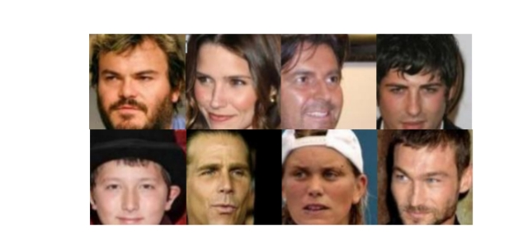

Figure 3.4: Samples from ’celebA’ dataset

**3.4.2 Iteration 2: Cropping faces from public datasets**

After facing some challenges with the previous technique of data preparation, new methodology was adopted in preparing face data. A pre-trained face detector network was used to crop faces, the cropped faces were not aligned or scaled. They were used as it is. 400k cropped faces were collected out of which 90% were used for training.

**3.4.3 Iteration 3: Aligning, Scaling, and Centering face data**

As discussed previously that generated faces have artifacts due to multi-modal data distribution, so as to reduce the multi-modularity of the data, faces were aligned, scaled and centered as a final step for data preparation. This helped reduce dimensionality of the face data. After applying the relevant transformations faces were cropped using pre-trained face detector and ’OpenCV’ python library.

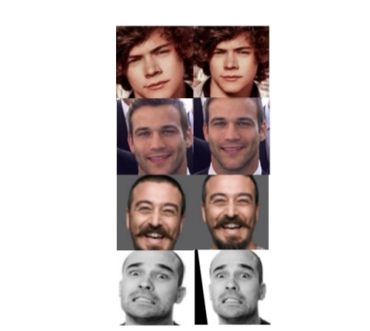

Figure 3.5: Cropped faces (Column 1), Aligned + Scaled + Cropped faces (Column 2)

**3.5 Suggested Algorithm for training of face anonymizer**

Once the data is collected the learning process starts. Algorithm below shows the utility function called ’PreProcess’. It is used to create input faces for the network.

’PreProcess’ function uses pre-trained facial landmark detector to detect landmarks like eyes, nose and lips. Using these landmarks, a facial mask is created with zeros at ’identity zone’ and ones otherwise. Identity zone is a convex hull of image pixels containing face information like eyes, nose and lips which helps identify person. ’PreProcess’ function returns the mask and a face in which the ’identity zone’ is deleted, let’s call this face as faceh (subscript h implies hollow face).

The first step is to initialize the generator neural network (GNN) and discriminator neural network (DNN). In each training step (iteration) a mini batch (say 10 images) of face images from shuffled dataset is processed. The ’PreProcess’ utility function is used to convert the faces (xo) into hollow faces (x). GNN tries to anonymize the face giving x’ as the output. ’Recreation’ and ’Adversarial’ losses are computed using generated face (x‘) and original face (xo). Weights (parameters) of the GNN and DNN are updated using the gradient of objective function. GNN tries to minimize joint loss function (loss joint) and DNN tries to minimize adversarial loss (lossadv). Training proceeds for used defined total training steps (iterations).

**3.6 Complete Pipeline**

Complete pipeline for anonymization of multiple faces in a frame consists of three parts:

* **PreProcess:** Crops out the faces from the input frame and saves some additional information.
* **Anonymize:** Anonymizes all the faces.
* **Postprocess:** Stitches back all the faces to the original frame

**3.6.1 Pre-Processing**

’PreProcess’ function takes the full frame as input. It detects, transforms and crops the faces. It also computes inverse transformations which are used during post-processing to stitch the faces back to the original frame. For each face, facial landmarks are detected using pre-trained landmark detector which are used to create a facial mask. Facial mask is used to delete the ’identity zone’ and the resulting faces (facesh) are sent for anonymization.

**3.6.2 Anonymization**

Trained generator network (GNN) is loaded and is used to anonymize faces.

**3.6.3 Post processing**

Anonymized faces (facesa) are transformed back to original form using inverse transformation matrices (invTransformations) and stitched back to original frame. This ends the process of face anonymization.

**CHAPTER-4**

# IMPLEMENTATION

**Algorithm 1: Data preparation algorithm.**

1. Function prepareData (humanData)
2. foreach image I ∈ humanData do
   1. faces = DetectFaces(I) // Uses a pre-trained face detector to find multiple faces in the photo.
   2. faces = TransformFaces (faces) // Transformations such as scaling, centering and rotating are applied.
   3. Save(faces) // Cropped, aligned and scaled faces are saved to the new data-base.

**Algorithm 2: Utility function: PreProcess**

Function PreProcess (faceo)

l = DetectLandmarks(faceo) // Detects facial landmarks like eyes, nose and lips. Subscript o implies original face

M = CreateMask(l) // Creates a facial mask M using the landmarks, let’s call it ’identity zone’.

faceh = M ∗ faceo // Multiplies mask M to the input image to create a face image in which identity zone is masked. Subscript h implies hollow face

10 return M, faceh

**Algorithm 3: Training process for face anonymization**.

Function Train (dataset)

GNN = InitGNN () // Initializes the face anonymization neural network.

DNN = InitDNN () // Initializes the discriminator neural network.

while iterations < Total iterations do

Sample a minibatch of images xo from training data.

M, x = PreProcess (xo) // Pre-processes the faces as defined in ’PreProcess’ function.

X’ = GNN(x) // Generator Neural Network takes hollow face and outputs a completed face.

lossrec = RecreationLoss (x’, xo, M) // Computes the value of Recreation loss function which show similarity in the context of the original and generated faces

lossadv = AdversarialLoss (DNN (xo), DNN (x 0)) // Computes adversarial loss. Discriminator network discriminates between real and generated faces so lower adversarial loss means discriminator is good with distinguishing between real and generated faces.

lossjoint = λrec ∗ lossrec − λadv ∗ lossadv // Notice the negative sign multiplied to adversarial loss

Update the weight of GNN in the direction that minimizes lossjoint. // Minimizes recreation loss and maximizes adversarial loss

Update the weight of DNN in the direction that minimizes lossadv.

return GNN

**Algorithm 4: Complete pipeline to anonymize multiple faces in a frame.**

Function Main (frame)

f aces, M, invT = PreProcess (frame)

facesa = Anonymize (f aces)

frame = PostProcess (frame, facesa, f aces, M, invT)

return frame

**Algorithm 5: Pre-Processing**

Function PreProcess (frame)

faces = DetectF aces(frame) // Uses a pre-trained face detector to find multiple faces in the frame.

faces, invTransformations = TransformFaces (f aces) // Transformations such as scale and rotation are applied and inverse transformations are saved for stitching back the anonymized faces to the original frame

foreach face fo ∈ f aces do

l = DetectLandmarks(fo) // Detects facial landmarks like eyes, nose and lips. Subscript o implies original face

Mi = CreateMask(l) // Creates a facial mask M using the landmarks, let’s call it ’identity zone’.

fh = Mi ∗ fo // Multiplies mask M to the input image to create a face image in which identity zone is masked. Subscript h implies hollow face

facesh.insert(fh) // Subscript h implies hollow faces

M.insert (Mi)

return faces, facesh, M, invTransformations

**Algorithm 6: Anonymization**

Function Anonymize (facesh)

GNN = LoadTrainedNN () // Loads the trained face anonymization network.

facesa = GNN (facesh) // Generator network (face anonymization network) takes hollow faces and returns a completed face. Subscript a implies anonymized faces

return facesa

**Algorithm 7: Post processing**

Function PostProcess (frame, facesa, faces, M, invTransformations)

foreach index i ∈ TotalFaces do

faceout = M ∗ f aces[i] + (1 − M) ∗ facesa[i] // keep the original face image and only use identity region from generated face.

faceout = invTransformations[i] ∗ faceout // Tranform the face back to the form so that it can be stitched to the original frame.

StitchFaceToFrame (faceout, frame)

end

return frame

**CHAPTER-5**

# EXPERIMENTAL RESULTS

**5.1 Training Results**

Nvidia GTX geforce 1080 GPU with 11GB of memory was used while training the neural network. 400k images of resolution 256 × 256 took 9 days of training time to achieve good results. For 60k images it took 2 days train the model.

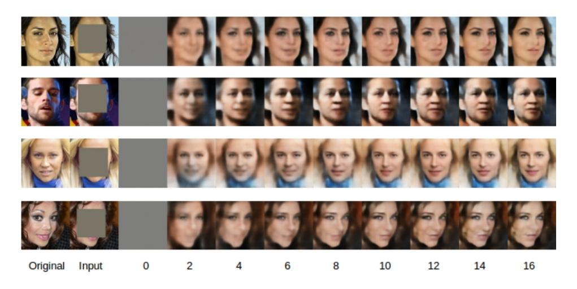

Figure 5.1: Training progress for first 16 epochs (16*400,000/10 = 640,000 iterations). Images from Column 3 onwards represents outputs from the network after every alternate epoch.

**5.2 Experiments to check ’Recreation Loss’**

As shown in Section 3.3.1 that recreation loss is designed to re-create the context from the original image. Just to check if this idea is working correctly, we tried black and white faces and it worked as expected as it created a black and white face as an anonymized face. We also tried an image with incomplete glasses and the trained anonymizer was able to complete the glasses. In one of the tests runs a ’shirt button’ was detected as a face and was sent for anonymization and to our surprise a meaningful face was created inside the button in the same context of the button. Figure 5.2 shows the results for the above three experiments and proves that recreation loss is doing its job, of keeping the same context as input face image, pretty well.

**5.3 Experiments with Face Masking**

The basic idea behind face anonymization was to delete the important portions (’identity zone’) of the face, which are important to identify a person, like eyes, nose, lips etc. Pre-trained landmark detector was used to detect facial landmarks. After the landmarks were detected various geometrical functions from OpenCV library were used to create a bounded region (convex hull) around facial landmarks. Thus, we ended up with various kind of facial mask which were used to hide the identity of the original person.

After the manual inspection of results using various mask, it was concluded that level of anonymization depends on the area of the mask and not on the shape. The same can be observed in Figure 5.4, by using a simple square mask the major portion of the face is deleted and the output face looks very different from the original face compared to results using ’T’ or ’X’ mask. So, a simple square mask was used as the preferred choice of the mask for all the further experiments.

**5.4 Experiments in Data Preparation**

The first experiment in data preparation was to use cropped face images from an existing database called ’celebA’. Results seemed promising as the training proceeded. During the training, random samples from training data were used to test the algorithm and it showed good results. Network also performed well with test data (10% of ’celebA’ data which was never used during training). But the network didn’t work well with validation set. Validation set contained data which was taken from real life scenario and not from the cropped ’celebA’ data, so faces were cropped with own algorithm as ’celebA’ data provider didn’t make their algorithm public. So, the validation set had different specifications compared to ’celebA’ dataset. And due to manual cropping of validation data, which was not exactly same as in ’celebA’ dataset, the network produced bad results. After this instead of using ’celebA’ dataset for training, lots of images of people were downloaded which contained full body images of ’people in the wild’.

An algorithm was designed to manually crop faces using ’OpenCV’ and ’dlib’ library in python. And the same cropping algorithm was used for training, testing and validation data preparation. This led to achieving meaningful results.

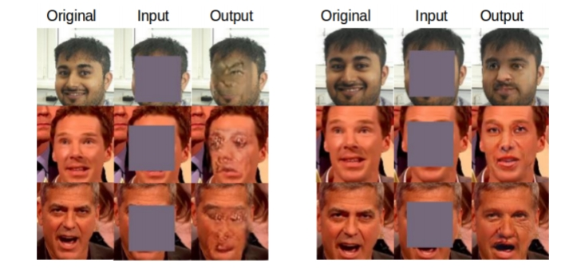

Figure 5.2: a) Using existing dataset. b) Manual data preparation.

**Results:** Structure of the data matters in training. Same pre-processing should be used for images while training, testing and validation. So, the only way to make this work is to use an own cropping algorithm which will also be used in the final application.

**Final data preparation algorithm:** Now that one problem was solved it was found that there is still a structural difference in the data. The data set which has been prepared by own cropping algorithm doesn’t contain all possible aspect ratio and rotations of the faces. So, if the model is trained on faces with specific aspect ratio and specific rotations than it will not generalize well because it will produce bad results for rotations and aspect-ratios which were not present in the training data. Another problem with adversarial training is that whenever you have multi-modal data then it tries to give a sample which can be a combination of multiple modals. Therefore, even though GAN models are currently able to generate realistic images, but due to the high dimensionality of a 2D grid of pixels, a key challenge for them is to generate images with coherent structure.

So as a final experiment with data preparation, faces were aligned, scaled and centered to reduce the multi-modularity of the dataset. This approach is better as the face transformations are cheaper than collecting 100 times more data in all possible rotations and aspect ratios. The only extra effort was to save inverse transformations as it was required to stitch back the faces to the full frame.

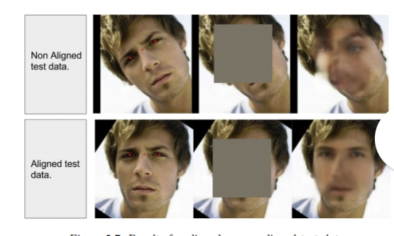

Figure 5.3: Results for aligned vs non-aligned test data

**Results**: If we align, scale and centre the face the network is able to easily generate realistic faces, which is not the case when we test it with random alignment and scaling. It gives bizarre results with non-aligned faces; network tries to fit straight face into tilted input. Thus, the network doesn’t generalize well for random alignments of the face.

**5.5 Experiment with Deeper network**

One of the current limitations of GANs is the inability to produce high resolution results. All the initial experiments were done using 128 × 128 face images, which was not the best resolution for real applications. 128 × 128 face stitched in high resolution frame looked like bad patch with low resolution. Simple way to solve this problem was to change the network to a network which takes higher resolution faces as input and outputs high resolution anonymized faces. This was achieved by adding an extra convolution layer in the beginning of the encoder and by adding an extra deconvolution layer at the end of decoder network.

**Results** This resulted in the improvement of the results, which proved to be useful for the final application. 256 × 256 resolution images gave better looking results when stitched to the original frame. Though this led to the doubling of the training time. It takes around 8-10 days, with 400k images of 256 × 256 resolution, to train the face anonymizer compared to 4-5 days for 128 × 128 resolution images.

**5.6 Experiments with Recreation Loss function**

L1 and L2 were tried as ’Recreation loss’. It was found that L2 produces blurry results. Though L1 performed a bit better than L2 loss. The simple loss function like L2 helps the generator to produce a rough outline of the face, but it often fails to capture high frequency details. This happens because L2 loss often prefer a blurry solution, over highly accurate textures. This happens because it is much safer for the L2 loss to predict the mean of the distribution, because this minimizes the mean pixel-wise error, but results in a blurry averaged image.

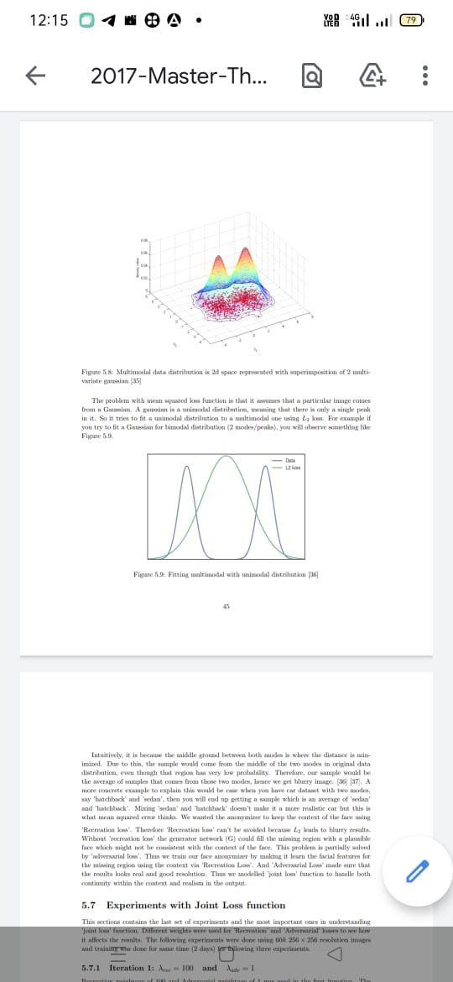Face dataset is also a multi-modal dataset. For example, there could be cluster of faces according to gender, skin color, age etc. Therefore, multiple gaussians will be needed to fit this type of data and the problem with L2 loss is that it tries to fit this data using single gaussian, which leads to blurry results.

Figure 5.4: Multimodal data distribution is 2d space represented with superimposition of 2 multivariate gaussian

The problem with mean squared loss function is that it assumes that a particular image comes from a Gaussian. A gaussian is a unimodal distribution, meaning that there is only a single peak in it. So, it tries to fit a unimodal distribution to a multimodal one using L2 loss. For example, if you try to fit a Gaussian for bimodal distribution (2 modes/peaks).



Figure 5.5: Fitting multimodal with unimodal distribution

Intuitively, it is because the middle ground between both modes is where the distance is minimized. Due to this, the sample would come from the middle of the two modes in original data distribution, even though that region has very low probability. Therefore, our sample would be the average of samples that comes from those two modes; hence we get blurry image. A more concrete example to explain this would be case when you have car dataset with two modes, say ’hatchback’ and ’sedan’, then you will end up getting a sample which is an average of ’sedan’ and ’hatchback’. Mixing ’sedan’ and ’hatchback’ doesn’t make it a more realistic car but this is what mean squared error thinks. We wanted the anonymizer to keep the context of the face using ’Recreation loss’.

Therefore ’Recreation loss’ can’t be avoided because L2 leads to blurry results. Without ’recreation loss’ the generator network (G) could fill the missing region with a plausible face which might not be consistent with the context of the face. This problem is partially solved by ’adversarial loss’. Thus, we train our face anonymizer by making it learn the facial features for the missing region using the context via ’Recreation Loss’. And ’Adversarial Loss’ made sure that the results look real and good resolution. Thus, we modelled ’joint loss’ function to handle both continuity within the context and realism in the output.

**5.7 Experiments with Joint Loss function**

This section contains the last set of experiments and the most important ones in understanding ’joint loss’ function. Different weights were used for ’Recreation’ and ’Adversarial’ losses to see how it affects the results. The following experiments were done using 60k 256 × 256 resolution images and training was done for same time (2 days) for following three experiments.

**5.7.1 Iteration 1: λrec = 100 and λadv = 1**

Recreation weightage of 100 and Adversarial weightage of 1 was used in the first iteration. The formulation of loss function is such that even after giving weightage of 100 to ’Recreation loss’, ’Adversarial loss’ still dominates. As it can be observed in the Figure 5.10 there are some artifacts in the output faces. Last three columns in the figure shows the anonymized results. 3rd Column has some sort of artifacts near the eyes. This happens because ’Adversarial loss’ thinks joining multiple eyes make it a more realistic face. This situation is improved by increasing the weightage for ’Recreation loss’.

Ljoint = 100 ∗ Lrec + 1 ∗ Ladv

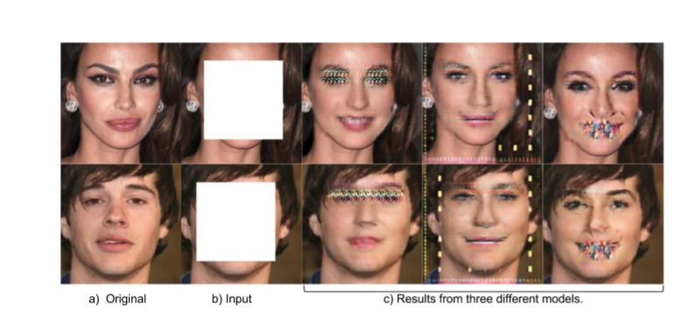

Figure 5.6: Results with λrec = 100 and λadv = 1

**5.7.2 Iteration 2: λrec = 500 and λadv = 1**

We observed better results by increasing the weightage for ’Recreation Loss’ to 500. The faces looked more realistic, artifacts didn’t appear and resolution was good. But one drawback was that the trained Generator network was not stable i.e., it didn’t work well for some input faces.

Ljoint = 500 ∗ Lrec + 1 ∗ Ladv

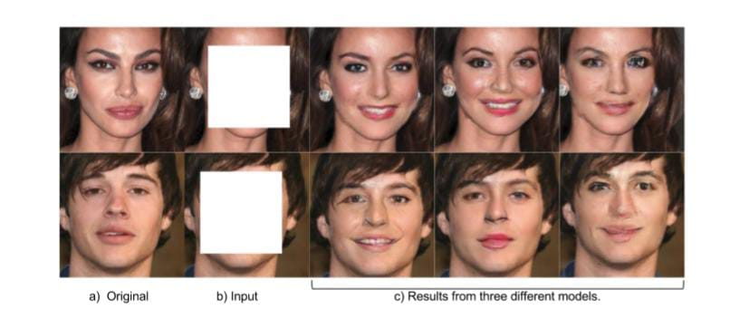

Figure 5.7: Results with λrec = 500 and λadv = 1

**5.7.3 Iteration 3: λrec = 1000 and λadv = 1**

In the last experiment we increased the weightage for ’Recreation loss’ to 1000. This gave smoother and stable results but faces were a bit blurry. As explained in the Section 5.6 the ’Recreation loss’ or specifically L2 loss leads to blurry images due to averaging effect.

Ljoint = 1000 ∗ Lrec + 1 ∗ Ladv

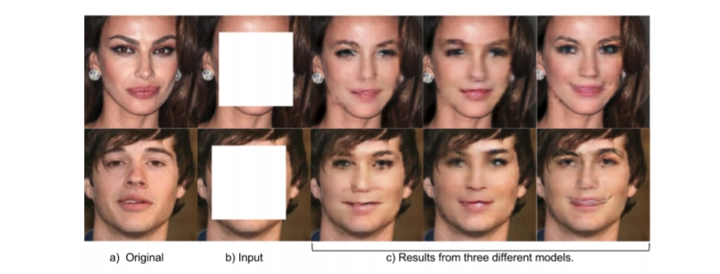

Figure 5.8: Results with λrec = 1000 and λadv = 1

**Comparison** Both ’Adversarial Loss’ and ’Recreation Loss’ are necessary as they both serve their own purpose. Recreation loss helps keep the context and Adversarial loss helps generate realistic and good resolution images. But both the loss functions have their side-effects. Too much ’Adversarial loss’ leads to artifacts and too much ’Recreation loss’ leads to blurry images. Thus, it’s a trade-off between two of them. With better evaluation metric for quality of generated faces that sweet spot can be achieved.

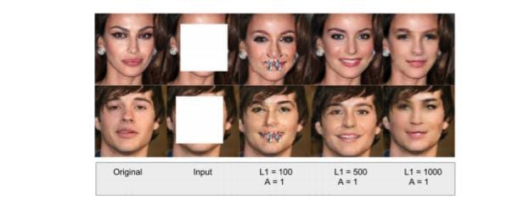

Figure 5.9: Comparison: Joint Loss variations.

**Additional Results**

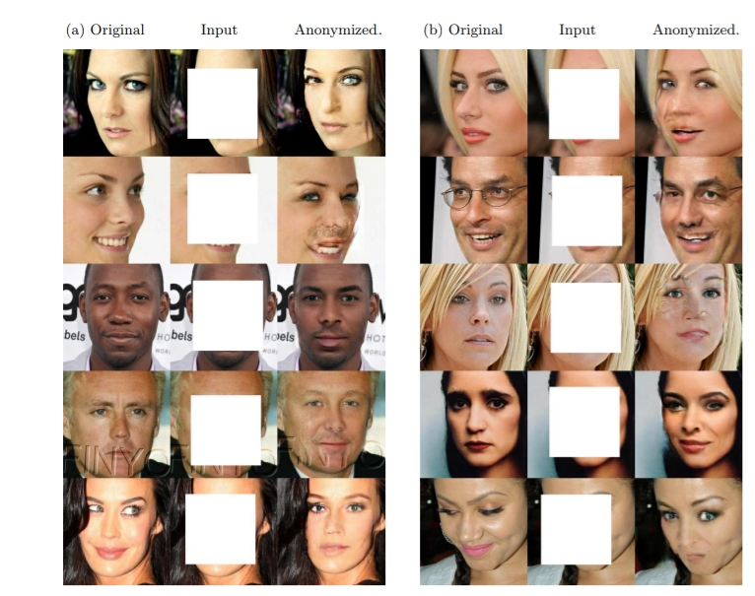

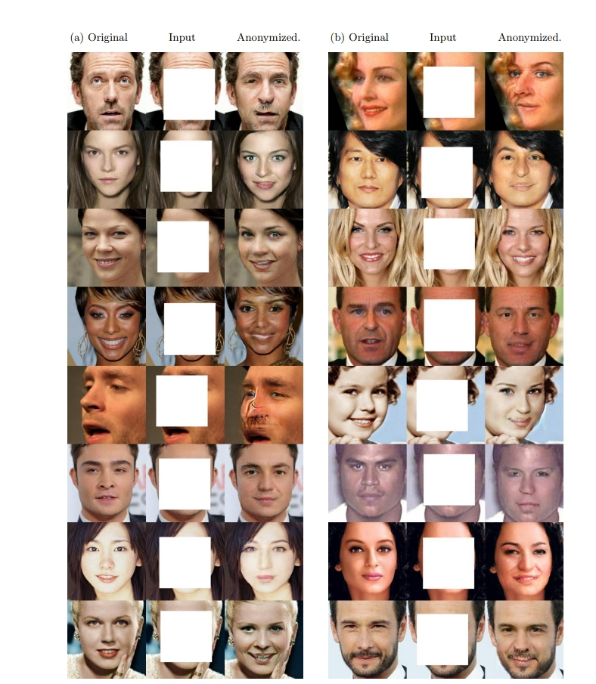Figure 5.10: Additional Results (both a and b) with λrec = 500 and λadv = 1 trained for 60k images of 256 × 256 resolution.

Figure 5.11: Additional Results (both a and b) with λrec = 500 and λadv = 1 trained for 60k images of 256 × 256 resolution.

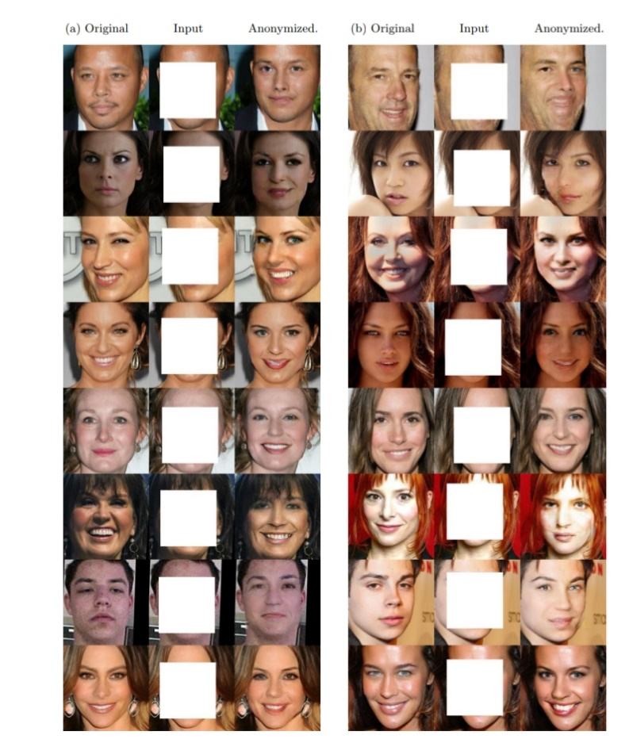

Figure 5.12: Additional Results (both a and b) with λrec = 500 and λadv = 1 trained for 60k images of 256 × 256 resolution.

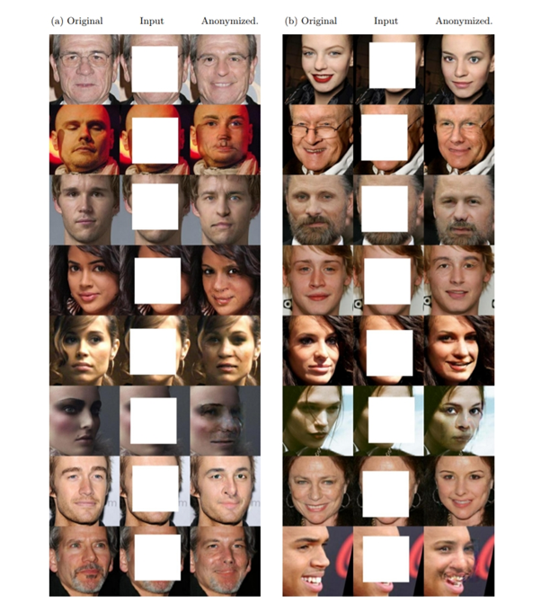

Figure 5.13: Additional Results (both a and b) with λrec = 500 and λadv = 1 trained for 60k images of 256 × 256 resolution.

**CHAPTER-6**

# CONCLUSION & FUTURE WORK

**6.1 Conclusions**

We have designed a prototype to anonymize faces which is better than traditional anonymization techniques like blurring, pixelation and cutting of faces. Unlike traditional anonymization techniques our method produces anonymized faces that looks realistic and can be used for artificial intelligence applications thus it preserves the utility of the data. Through our experiments, we have demonstrated the efficacy and potential of using Generative Adversarial Network to anonymize faces with 80% Learning rate. In particular, we have shown that formulating the task as a face completion task can yield anonymized faces that are aesthetically-pleasing and real looking than the orthodox face anonymization techniques and thus shows much promise for further development. We designed a joint loss function as an objective function to successfully train the face anonymizer neural network. We also designed a full end-to-end pipeline to anonymize multiple faces in a frame smoothly. As an additional contribution, we constructed a high-quality face data which contains aligned, scaled and centered faces.

This work therefore lays a solid foundation for future work. We have also identified several avenues for improving our current system.

**6.2 Future Work**

* Evaluating the quality of synthesized images is an open and difficult problem. Though we have used mean-squared error as one of the criteria but it does not assess joint statistics of the result, and therefore do not measure the exact structures in the image. To evaluate the visual quality of our results, we used the plausibility to human observer to choose the model. As a future aspect, we can measure whether or not our synthesized faces are realistic enough that standard recognition system can recognize the objects in them. The intuition is that if the generated images are realistic, then the classifiers trained on real images will be able to classify the synthesized image correctly as well.
* One of the future tasks is to achieve conditional face anonymization i.e., to anonymize the face using extra user defined parameters like hair color, beard, gender etc. This can be achieved by incorporating conditional GAN setting in our framework.
* Another improvement can be addressing the issue of when to stop the training. We can consider incorporating Wasserstein gan idea into the model proposed in this thesis and get a better criterion to stop the training.
* To ascertain the anonymity of the photos we can use facial recognition network as a part of the ’joint loss’ function. This function will give a similarity score for original and anonymized image in terms of the identity of the person. Maximizing this score will put the pressure for anonymization.
* For achieving better resolution, we can utilize the latest research in this area. ’Progressive growing of GANs’ and ’super-resolution by GANs’ are two great contributions in this direction.

# REFERENCES

[1] Mehdi Mirza Bing Xu David Warde-Farley Sherjil Ozair Aaron Courville Yoshua Bengio Ian J. Goodfellow, Jean Pouget-Abadie. Generative adversarial nets. 2014.

[2] Soumith Chintala Alec Radford, Luke Metz. Unsupervised representation learning with deep convolutional generative adversarial networks. 2015.

[3] <https://en.wikipedia.org/wiki/General_Data_Protection_Regulation>.

[4] http://www.gamingtechlaw.com/2016/10/privacy-gdpr-artificial-intelligence. html.

[5] Bradley Malin Ralph Gross, Edoardo Airoldi and Latanya Sweeney. Integrating utility into face de-identification.

[6] Reza Shokri Richard McPherson and Vitaly Shmatikov. Defeating image obfuscation with deep learning. 2016.

[7] Samuli Laine Jaakko Lehtinen Tero Karras, Timo Aila. Progressive growing of gans for improved quality, stability, and variation. 2017.

[8] Artur Luczak Volodymyr Turchenko, Eric Chalmers. A deep convolutional auto-encoder with pooling - unpooling layers in caffe. 2017.

[9] <http://neuralnetworksanddeeplearning.com/chap6.html>.

[10] K. Simonyan and A. Zisserman. Very deep convolutional networks for large-scale image recognition. 2014.

[11] H. Su J. Krause S. Satheesh S. Ma-Z. Huang A. Karpathy A. Khosla M. Bernstein A. C. Berg O. Russakovsky, J. Deng and L. Fei-Fei. ImageNet large scale visual recognition challenge. 2015.

[12] A. Graves D. Jimenez Rezende K. Gregor, I. Danihelka and D. Wierstra. Draw: A recurrent neural network for image generation. 2015.

[13] W. Zaremba V. Cheung A. Radford T. Salimans, I. J. Goodfellow and X. Chen. Improved techniques for training gans. 2015.

[14] Jurgen Schmidhuber. Deep learning in neural networks: An overview. 2014

[15] Kunihiko Fukushima. Neocognitron: A self-organizing neural network model for a mechanism of pattern recognition unaffected by shift in position. 1980.

[16] Ian Goodfellow, Yoshua Bengio, and Aaron Courville. Deep Learning. MIT Press, 2016. <http://www.deeplearningbook.org>.

[17] <http://cs231n.github.io/neural-networks-1/>.

[18] Alex Krizhevsky, Ilya Sutskever, and Geoffrey E Hinton. ImageNet classification with deep convolutional neural networks. In F. Pereira, C. J. C. Burges, L. Bottou, and K. Q. Weinberger, editors, Advances in Neural Information Processing Systems 25, pages 1097–1105. Curran Associates, Inc., 2012.

[19] Hidenori Ide and Takio Kurita. Improvement of learning for cnn with relu activation by sparse regularization. 2017.

[20] Matthew D. Zeiler and Rob Fergus. Visualizing and understanding convolutional networks. https://arxiv.org/, 2013.

[21] https://github.com/vdumoulin/conv_arithmetic.

[22] <http://cs231n.github.io/convolutional-networks/>.

[23] http://deeplearning.net/software/theano_versions/dev/tutorial/conv_arithmetic. html.

[24] Sergey Ioffe and Christian Szegedy. Batch normalization: Accelerating deep network training by reducing internal covariate shift. https://arxiv.org/, 2015.

[25] Bogdan Raducanu Guim Perarnau, Joost van de Weijer and Jose M. lvarez. Invertible conditional gans. https://arxiv.org/, 2016.

[26] Min Peng and Chongyang Wang. Nirfacenet: A convolutional neural network for near-infrared face identification. http://www.mdpi.com/, 2016.

[27]https://medium.com/deeper-learning/glossary-of-deep-learning-autoencoder-1044ec82c300.

[28] J urgen Schmidhuber Alex Graves, Santiago Fernandez. Multi-dimensional recurrent neural networks. 2013.

[29] <http://www.wildml.com/2015/09/recurrent-neural-networks-tutorial-part-1-introduction-to-rnns/>.

[30] <https://medium.com/@awjuliani/generative-adversarial-networks-explained-with-a-classic-spongebob-squarepants-episode-54deab2fce39>.

[31] N. Jaitly A. Makhzani, J. Shlens and I. Goodfellow. Adversarial autoencoders. 2015.

[32] Wojciech Marian Czarnecki Katarzyna Janocha. On loss functions for deep neural networks in classification. 2017.

[33] Ziwei Liu, Ping Luo, Xiaogang Wang, and Xiaoou Tang. Deep learning face attributes in the wild. In Proceedings of International Conference on Computer Vision (ICCV), 2015.

[34] https://github.com/NVIDIA/DIGITS/blob/master/examples/gan/celeba-embeddings. gif.

[35] <https://commons.wikimedia.org/wiki/File:Bivariate_example.png>.

[36] <https://wiseodd.github.io/techblog/2017/02/09/why-l2-blurry/>.

[37] Alexei A. Efros Richard Zhang, Phillip Isola. Colorful image colorization. 2016.

[38] Munyoung Kim Jung-Woo Ha Sunghun Kim Jaegul Choo Yunjey Choi, Minje Choi. Stargan: Unified generative adversarial networks for multi-domain image-to-image translation. 2017.

[39] Lon Bottou Martin Arjovsky, Soumith Chintala. Wasserstein gan. 2017.

[40] Marc Aurelio Ranzato Yaniv Taigman, Ming Yang. Deepface: Closing the gap to human-level performance in face verification. 2015.

[41] Phillip Isola, Jun-Yan Zhu, Tinghui Zhou, and Alexei A Efros. Image-to-image translation with conditional adversarial networks. 2016.